

**Insert School Logo**

**HUMAN BIOLOGY**

**Unit 3 and 4**

**2019**

Name: \_\_\_\_\_\_\_\_\_\_\_\_\_\_\_\_\_\_\_\_\_\_\_\_\_\_\_\_\_\_\_\_\_\_\_\_\_\_\_\_\_\_\_\_\_\_\_\_\_\_\_\_\_\_\_

Teacher: \_\_\_\_\_\_\_\_\_\_\_\_\_\_\_\_\_\_\_\_\_\_\_\_\_\_\_\_\_\_\_\_\_\_\_\_\_\_\_\_\_\_\_\_\_\_\_\_\_\_\_

**Time allowed for this paper**

Reading time before commencing work: ten minutes

Working time for the paper: three hours

**Materials required/recommended for this paper**

***To be provided by the supervisor***

This Question/Answer Booklet

Multiple-choice Answer Sheet

***To be provided by the candidate***

Standard items: pens (blue/black preferred), pencils (including coloured), sharpener, correction fluid/tape, eraser, ruler, highlighters

Special items: non-programmable calculators approved for use in this examination

**Important note to candidates**

No other items may be taken into the examination room. It is **your** responsibility to ensure that you do not have any unauthorised material. If you have any unauthorised material with you, hand it to the supervisor **before** reading any further.

**Structure of this paper**

|  |  |  |  |  |  |
| --- | --- | --- | --- | --- | --- |
| Section | Number of questions available | Number of questions to be answered | Suggested working time (minutes) | Marks available | Percentage of examination |
| Section One  Multiple-choice | 30 | 30 | 40 | 30 | 30 |
| Section Two  Short answers | 8 | 8 | 90 | 100 | 50 |
| Section Three  Extended answers | 3 | 2 | 50 | 40 | 20 |
|  |  |  |  | **Total** | 100 |

**Instructions to candidates**

1. The rules for the conduct of the Western Australian examinations are detailed in the *Year 12 Information Handbook 2019*. Sitting this examination implies that you agree to abide by these rules.

2. Write your answers in this Question/Answer booklet preferably using a blue/black pen. Do not use erasable or gel pens.

3. Answer the questions according to the following instructions.

Section One: Answer all questions on the separate Multiple-choice answer sheet provided. For each question, shade the box to indicate your answer. Use only a blue or black pen to shade the boxes. Do not use erasable or gel pens. If you make a mistake, place a cross through that square, then shade your new answer. Do not erase or use correction fluid/tape. Marks will not be deducted for incorrect answers. No marks will be given if more than one answer is completed for any question.

Section Two: Write your answers in this Question/Answer booklet. Wherever possible, confine your answers to the line spaces provided.

Section Three: Consists of three questions. You must answer two questions. Tick the box next to the question you are answering. Write your answers in this Question/Answer booklet.

4. You must be careful to confine your answers to the specific questions asked and to follow any instructions that are specific to a particular question.

5. Supplementary pages for planning/continuing your answers to questions are provided at the end of this Question/Answer booklet. If you use these pages to continue an answer, indicate at the original answer where the answer is continued, i.e. give the page number.

**Section One: Multiple-choice 30% (30 Marks)**

This section has **30** questions. Answer all questions on the separate Multiple-choice answer sheet provided. For each question shade the box to indicate your answer. Use only a blue or black pen to shade the boxes. Do not use erasable or gel pens. If you make a mistake, place a cross through that square, then shade your new answer. Do not erase or use correction fluid/tape. Marks will not be deducted for incorrect answers. No marks will be given if more than one answer is completed for any question.

Suggested working time: 40 minutes.

1. Below is a list of steps used in the creation of a DNA profile using gel electrophoresis.
2. DNA being negatively charged, migrates to the positive electrodes
3. PCR is run to amplify the amount of DNA
4. Loading dye is added to samples
5. DNA image is transferred to a membrane
6. All samples are treated with restriction enzymes
7. Samples are loaded into wells and electricity is switched on

Which of the following identifies the **correct** order of steps for conducting gel electrophoresis?

* 1. iii 🡪 i 🡪 v
  2. iii 🡪 iv 🡪 v
  3. v🡪 iv 🡪 iii
  4. iii 🡪 i 🡪 iv

1. Some rare autosomal recessive conditions confer an advantage to those that are heterozygous for the condition in certain environmental situations. Which of the following diseases shows this?
   1. Diabetes
   2. Hypothyroidism
   3. Tay-Sachs
   4. Alzheimer’s
2. A body structure that has different internal structures but performs a similar function in distantly related organisms is an example of
   1. a pentadactyl limb.
   2. a vestigial organ.
   3. a fossil.
   4. an analogous structure.
3. Which of the following is an example of natural passive immunity?
   1. vaccinations
   2. becoming infected with the disease
   3. antibodies passed through breast milk
   4. being injected with antibodies
4. The olfactory cells in the nasal cavities that detect smells would be an example of
   1. thermoreceptors.
   2. mechanoreceptors.
   3. chemoreceptors.
   4. pain receptors.
5. The ascending tracts contained in the white matter of the spinal cord
   1. carry sensory information to the brain.
   2. conduct nerve impulses down the spinal cord to lower motor neurons.
   3. contain motor axons to carry nerve impulses away from the peripheral nervous system.
   4. carry sensory information away from the brain.
6. Which of the following structures are found in the *Homo sapiens* knee to support bipedalism?
   1. the carrying angle
   2. meniscus
   3. the bursae
   4. broad epiphysis
7. Treatment for diabetes mellitus using gene therapy could include
   1. injecting stem cells into the pancreas of the diabetes patient.
   2. infecting the patient’s pancreatic cells with modified viral cells containing the insulin producing gene.
   3. fitting the patient with an insulin pump.
   4. transferring healthy pancreatic tissue from a donor into a patient suffering from diabetes mellitus.
8. A Human Biology student was doing an experiment to measure the impact exercise has on heart rate. Her hypothesis was that ‘Exercise causes an increase in heart rate”. After pretesting, the student changed her method from measuring heart rate using two fingers on the radial artery, to wearing a heart rate monitor. This change was made so that her measurement method better matched her hypothesis. This change was made to improve
   1. reliability.
   2. validity.
   3. accuracy.
   4. controllability.
9. The part of the brain responsible for the autonomic regulation of body temperature and osmotic pressure is the
   1. medulla oblongata.
   2. hypothalamus.
   3. cerebrum.
   4. cerebellum.
10. Which of the following shows **correct** pairings of endocrine organ and the hormone it produces?
    1. pineal gland, melatonin; anterior pituitary gland, growth hormone; adrenal cortex, adrenaline
    2. posterior pituitary gland, oxytocin; anterior pituitary gland, prolactin; ovaries, follicle stimulating hormone
    3. ovaries, oestrogen; thymus, thymosins; adrenal cortex, noradrenaline
    4. adrenal medulla, cortisol; testes, androgens; anterior pituitary gland, growth hormone
11. A person suffering from weight loss, rapid heartbeat and anxiety has been prescribed medication from their doctor. They are most likely to be suffering from
    1. hypothyroidism.
    2. hyperthyroidism.
    3. type I diabetes.
    4. type II diabetes
12. Which of the following would be a **correct** example of ‘positive feedback’ in homeostasis?
    1. shivering when internal temperature is too low
    2. uterine contractions during child birth
    3. having a drink when you feel thirsty
    4. breathing faster when your body detects increased blood CO2
13. All of the following are applications of ‘bioinformatics’ except which one?
    1. tracing the evolution of large numbers of organisms
    2. annotations of genes and other biological features in DNA sequences
    3. comparing genomes of different organisms
    4. prescribing medications to individuals based on genetic make-up

Question 15 refers to the diagram below.

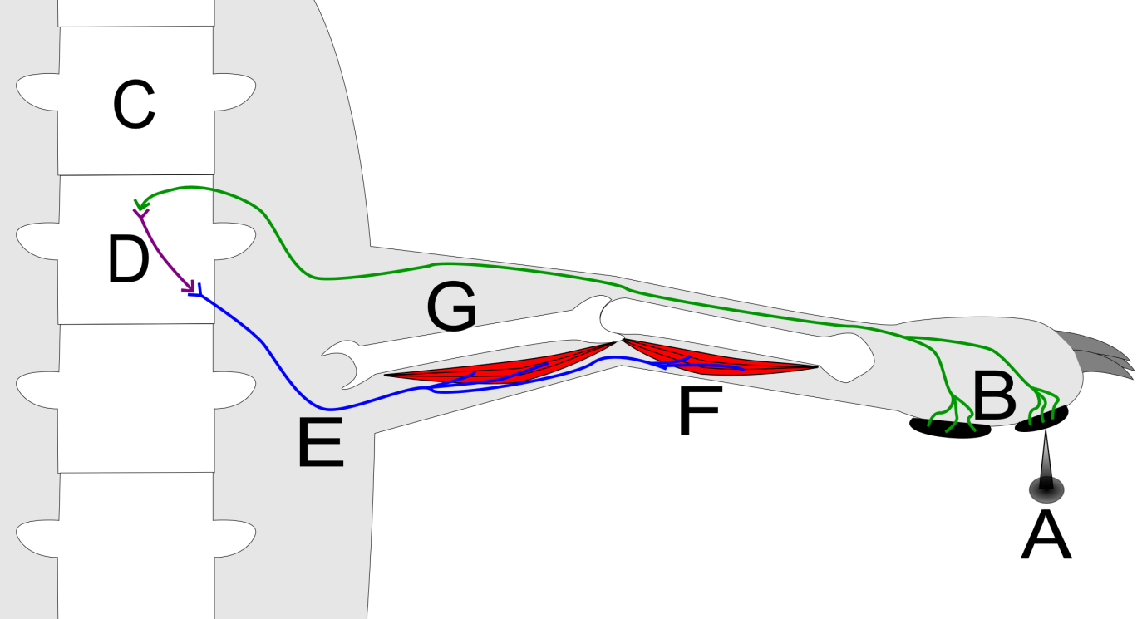

1. The structure labelled ‘D’ could be described as
   1. an afferent neuron carrying information away from the spinal cord.
   2. an efferent neuron carrying information toward the spinal cord.
   3. an interneuron transferring information from the afferent neuron to the efferent neuron.
   4. pain receptors in the skin transferring information to the afferent neuron.
2. Which of the following is **not** an example of an application of gel electrophoresis?
   1. paternity testing
   2. testing genetic material at crime scenes
   3. testing for disease genes
   4. amplifying DNA

Questions 17 and 18 refer to the diagram below.

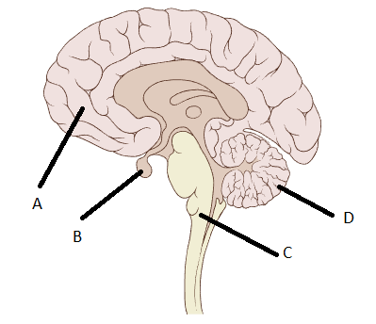

1. Which part of the brain coordinates voluntary motor movement?
   1. A
   2. B
   3. C
   4. D
2. Which part of the brain is a gland that produces many different hormones?
   1. A
   2. B
   3. C
   4. D
3. Which of the following is associated with the overuse of prescription antibiotics?
   1. causes hypoglycaemia
   2. development of developmental disorders
   3. acts as a diuretic
   4. antibiotic resistant bacteria
4. On hot days human beings start to sweat to try and cool the body down. What causes the sweating response?
   1. thermoreceptors in the hypothalamus detect the increase in temperature and sends nerve impulses to the sweat glands to start sweating
   2. thermoreceptors in the skin detect the increase in temperature and sends nerve impulses to the sweat glands to start sweating
   3. thermoreceptors in the hypothalamus detect the increase in temperature and secretes hormones to the blood stream that cause the sweat glands to start sweating
   4. thermoreceptors in the skin detect the increase in temperature and secrete hormones to the blood stream that cause the sweat glands to start sweating

Question 21 refers to the image shown below.

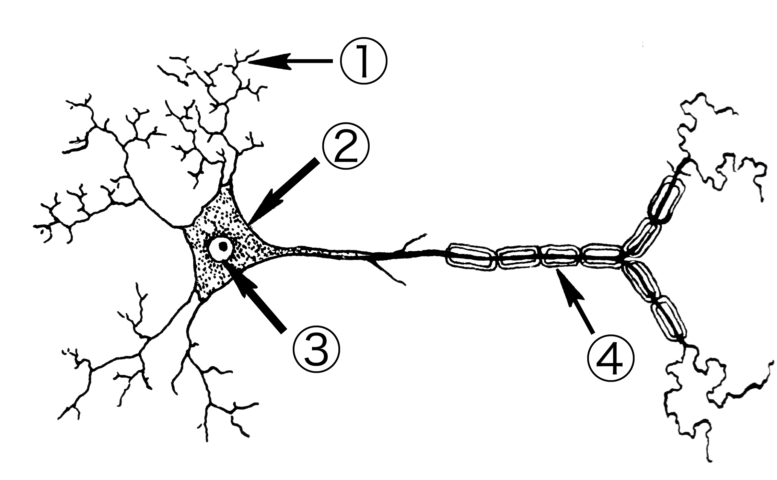

1. Which is the **correct** pairing of the labelled parts of the neuron?
   1. 1; axon terminals, 2; cell body, 3; nucleus, 4; Schwann cell
   2. 1; dendrites, 2; axon, 3; nucleus, 4; myelinated sheath
   3. 1; axon terminals, 2; axon hillock, 3; nucleus, 4; Schwann cell
   4. 1; dendrites, 2; cell body, 3; nucleus, 4; myelinated sheath
2. Which of the following pairings of receptors and stimuli is **incorrect**?
   1. chemoreceptors detect chemicals
   2. thermoreceptors detect temperature
   3. pain receptors detect sugar concentration
   4. osmoreceptors detect water concentration
3. Which is the best definition for an antigen?
   1. any substance capable of causing a specific immune response
   2. any organism that causes disease
   3. a substance produced in B-lymphocytes that stops bacterial proliferation
   4. a substance that is used in all vaccines
4. Which of the following shows the **correct** definition for the two main types of antibiotics?
   1. Bactericidal antibiotics kill bacteria; Bacteriostatic stop bacterial reproduction
   2. Bactericidal antibiotics kill bacteria; Bacteriostatic stop bacteria entering the cell membrane
   3. Bactericidal antibiotics kill bacterial infected cells; Bacteriostatic stop bacterial reproduction
   4. Bactericidal antibiotics kill bacterial infected cells; Bacteriostatic stop bacteria entering the cell membrane

Question 25 refers to the diagram below.

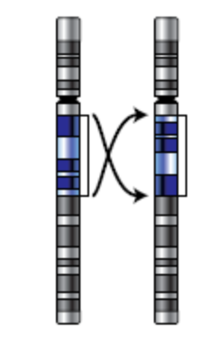

1. The type of mutation depicted above is known as
   1. a deletion.
   2. an inversion.
   3. a duplication.
   4. a translocation.
2. If a species becomes separated into two separate non-breeding populations, the separate gene pools might change over time to a point where the two populations can no longer interbreed. This is an example of
   1. founder effect.
   2. speciation.
   3. random genetic drift.
   4. a bottleneck event.

Question 27 refers to the diagram below of the forelimb of different organisms.

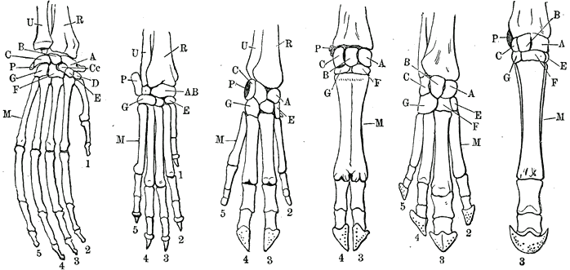

1. Which principle of comparative anatomy does the image show?
   1. vestigial organs
   2. homologous structures
   3. analogous structures
   4. embryology

Question 28 and 29 refer to the following information:

A Human Biology student did an investigation to measure the change in mass of two deshelled eggs, one in a salt solution and one in distilled water. After completing the experiment, she decided to repeat it with two new pairs of eggs.

1. Repeating the experiment helps to improve its
   1. reliability.
   2. validity.
   3. measurement error.
   4. accuracy.
2. Below are the results of the experiment.

|  |  |  |
| --- | --- | --- |
|  | **Change of mass in salt water (g)** | **Change of mass in distilled water (g)** |
| Egg 1 | -24 | +52 |
| Egg 2 | -31 | +71 |
| Egg 3 | -35 | +60 |
| Mean | X | Y |

Which of the following show the mean scores for each condition?

1. X= -29; Y=+60
2. X= 7; Y=19
3. X= -30; Y=+61
4. X= -31; Y= +60

Question 30 refers to the image below.

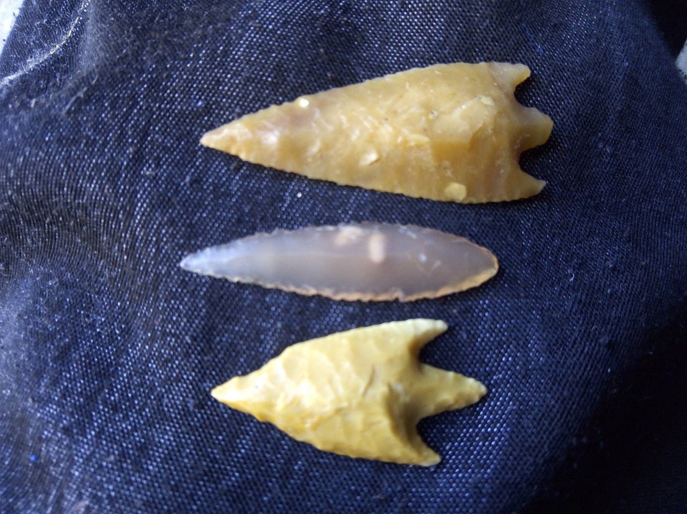

1. Which Homo species would be most likely to have manufactured the tools above?
   1. *Homo neanderthalensis*
   2. *Homo sapiens*
   3. *Homo erectus*
   4. *Homo habilis*

**Section Two: Short answer 50% (100 Marks)**

This section has **eight** questions. Answer **all** questions. Write your answers in the spaces provided.

Supplementary pages for planning/continuing your answers to questions are provided at the end of this Question/Answer booklet. If you use these pages to continue an answer, indicate at the original answer where the answer is continued, i.e. give the page number.

Suggested working time: 90 minutes.

**Question 31 (12 marks)**

A year 12 Human Biology student was interested to find out whether or not reaction times were affected by the use of the dominant or non-dominant hand. To test this the student found a reaction time test on the internet where you had to click the mouse when a coloured dot changed. She did the test five times with each hand.

The results are found below.

|  |  |  |
| --- | --- | --- |
| **Test number** | **Dominant hand (sec)** | **Non-Dominant (sec)** |
| 1 | 0.483 | 0.470 |
| 2 | 0.212 | 0.612 |
| 3 | 0.357 | 0.417 |
| 4 | 0.290 | 0.320 |
| 5 | 0.455 | 0.280 |

1. Calculate the median score for each condition. (2 marks)

Dominant hand: \_\_\_\_\_\_\_\_\_\_\_\_\_\_\_\_\_\_\_\_\_\_\_\_\_\_\_\_\_\_\_\_\_\_\_\_\_\_\_\_\_\_\_\_\_\_\_\_\_\_\_\_\_\_

Non-dominant hand: \_\_\_\_\_\_\_\_\_\_\_\_\_\_\_\_\_\_\_\_\_\_\_\_\_\_\_\_\_\_\_\_\_\_\_\_\_\_\_\_\_\_\_\_\_\_\_\_\_\_\_

1. Propose an appropriate hypothesis for this investigation. (1 mark)

\_\_\_\_\_\_\_\_\_\_\_\_\_\_\_\_\_\_\_\_\_\_\_\_\_\_\_\_\_\_\_\_\_\_\_\_\_\_\_\_\_\_\_\_\_\_\_\_\_\_\_\_\_\_\_\_\_\_\_\_\_\_\_\_\_\_\_\_\_\_\_\_\_\_\_\_\_\_\_\_\_\_\_\_\_\_\_\_\_\_\_\_\_\_\_\_\_\_\_\_\_\_\_\_\_\_\_\_\_\_\_\_\_\_\_\_\_\_\_\_\_\_\_\_\_\_\_\_\_\_\_\_\_\_

1. Name **two** variables that the student should have controlled to make the investigation fair. (2 marks)

\_\_\_\_\_\_\_\_\_\_\_\_\_\_\_\_\_\_\_\_\_\_\_\_\_\_\_\_\_\_\_\_\_\_\_\_\_\_\_\_\_\_\_\_\_\_\_\_\_\_\_\_\_\_\_\_\_\_\_\_\_\_\_\_\_\_\_\_\_\_\_\_\_\_\_\_\_\_\_\_\_\_\_\_\_\_\_\_\_\_\_\_\_\_\_\_\_\_\_\_\_\_\_\_\_\_\_\_\_\_\_\_\_\_\_\_\_\_\_\_\_\_\_\_\_\_\_\_\_\_\_\_\_\_

The student decided to conduct the same test on 10 of her class mates. Each participant had to complete the same test 5 times with each hand and then record the average.

The results are shown below.

|  |  |  |
| --- | --- | --- |
| **Participant number** | **Average dominant hand (sec)** | **Average non-dominant hand (sec)** |
| 1 | 0.361 | 0.384 |
| 2 | 0.411 | 0.521 |
| 3 | 0.172 | 0.169 |
| 4 | 0.223 | 0.256 |
| 5 | 0.311 | 0.320 |
| 6 | 1.100 | 1.421 |
| 7 | 0.228 | 0.308 |
| 8 | 0.201 | 0.212 |
| 9 | 0.199 | 0.212 |
| 10 | 0.318 | 0.310 |
| Average |  |  |

1. Use these results to create a graph showing the combined average time for the dominant hand and combined average time for the non-dominant hand. Graph this on the grid paper below. A spare grid is provided at the end of this Question/Answer booklet. If you need to use it, cross out this attempt. (5 marks)

|  |  |  |  |  |  |  |  |  |  |  |  |  |  |  |  |  |  |  |  |  |  |  |  |  |
| --- | --- | --- | --- | --- | --- | --- | --- | --- | --- | --- | --- | --- | --- | --- | --- | --- | --- | --- | --- | --- | --- | --- | --- | --- |
|  |  |  |  |  |  |  |  |  |  |  |  |  |  |  |  |  |  |  |  |  |  |  |  |  |
|  |  |  |  |  |  |  |  |  |  |  |  |  |  |  |  |  |  |  |  |  |  |  |  |  |
|  |  |  |  |  |  |  |  |  |  |  |  |  |  |  |  |  |  |  |  |  |  |  |  |  |
|  |  |  |  |  |  |  |  |  |  |  |  |  |  |  |  |  |  |  |  |  |  |  |  |  |
|  |  |  |  |  |  |  |  |  |  |  |  |  |  |  |  |  |  |  |  |  |  |  |  |  |
|  |  |  |  |  |  |  |  |  |  |  |  |  |  |  |  |  |  |  |  |  |  |  |  |  |
|  |  |  |  |  |  |  |  |  |  |  |  |  |  |  |  |  |  |  |  |  |  |  |  |  |
|  |  |  |  |  |  |  |  |  |  |  |  |  |  |  |  |  |  |  |  |  |  |  |  |  |
|  |  |  |  |  |  |  |  |  |  |  |  |  |  |  |  |  |  |  |  |  |  |  |  |  |
|  |  |  |  |  |  |  |  |  |  |  |  |  |  |  |  |  |  |  |  |  |  |  |  |  |
|  |  |  |  |  |  |  |  |  |  |  |  |  |  |  |  |  |  |  |  |  |  |  |  |  |
|  |  |  |  |  |  |  |  |  |  |  |  |  |  |  |  |  |  |  |  |  |  |  |  |  |
|  |  |  |  |  |  |  |  |  |  |  |  |  |  |  |  |  |  |  |  |  |  |  |  |  |
|  |  |  |  |  |  |  |  |  |  |  |  |  |  |  |  |  |  |  |  |  |  |  |  |  |
|  |  |  |  |  |  |  |  |  |  |  |  |  |  |  |  |  |  |  |  |  |  |  |  |  |
|  |  |  |  |  |  |  |  |  |  |  |  |  |  |  |  |  |  |  |  |  |  |  |  |  |
|  |  |  |  |  |  |  |  |  |  |  |  |  |  |  |  |  |  |  |  |  |  |  |  |  |
|  |  |  |  |  |  |  |  |  |  |  |  |  |  |  |  |  |  |  |  |  |  |  |  |  |

1. Which **one** of the participants could have been considered an outlier? Explain why.

(2 marks)

\_\_\_\_\_\_\_\_\_\_\_\_\_\_\_\_\_\_\_\_\_\_\_\_\_\_\_\_\_\_\_\_\_\_\_\_\_\_\_\_\_\_\_\_\_\_\_\_\_\_\_\_\_\_\_\_\_\_\_\_\_\_\_\_\_\_\_\_\_\_\_\_\_\_\_\_\_\_\_\_\_\_\_\_\_\_\_\_\_\_\_\_\_\_\_\_\_\_\_\_\_\_\_\_\_\_\_\_\_\_\_\_\_\_\_\_\_\_\_\_\_\_\_\_\_\_\_\_\_\_\_\_\_\_\_\_\_\_\_\_\_\_\_\_\_\_\_\_\_\_\_\_\_\_\_\_\_\_\_\_\_\_\_\_\_\_\_\_\_\_\_\_\_\_\_\_\_\_\_\_\_\_\_\_\_\_\_\_\_\_\_\_\_\_\_\_\_\_\_\_\_

**Question 32 (13 marks)**

The diagram below shows an action potential.

`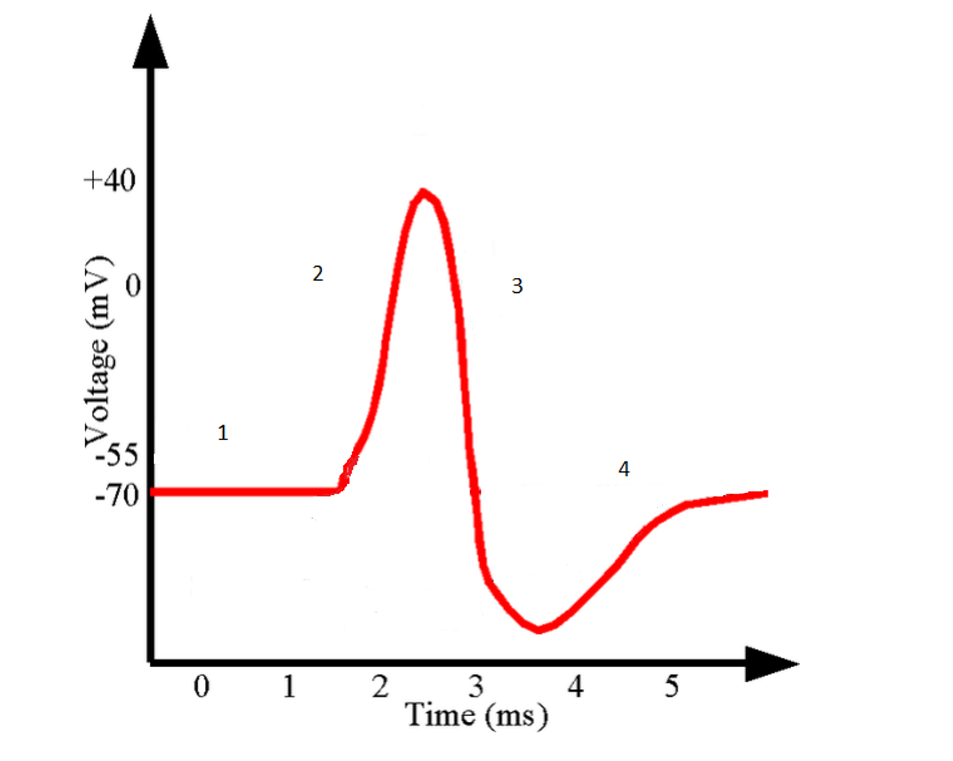

1. Add a label to the graph above showing when stimulation occurred. (1 mark)
2. Shade the area in the graph known as the refractory period. (1 mark)
3. Describe what is happening in the neuron during labels 2 and 3. (2 marks)

\_\_\_\_\_\_\_\_\_\_\_\_\_\_\_\_\_\_\_\_\_\_\_\_\_\_\_\_\_\_\_\_\_\_\_\_\_\_\_\_\_\_\_\_\_\_\_\_\_\_\_\_\_\_\_\_\_\_\_\_\_\_\_\_\_\_\_\_\_\_\_\_\_\_\_\_\_\_\_\_\_\_\_\_\_\_\_\_\_\_\_\_\_\_\_\_\_\_\_\_\_\_\_\_\_\_\_\_\_\_\_\_\_\_\_\_\_\_\_\_\_\_\_\_\_\_\_\_\_\_\_\_\_\_\_\_\_\_\_\_\_\_\_\_\_\_\_\_\_\_\_\_\_\_\_\_\_\_\_\_\_\_\_\_\_\_\_\_\_\_\_\_\_\_\_\_\_\_\_\_\_\_\_\_\_\_\_\_\_\_\_\_\_\_\_\_\_\_\_\_\_

**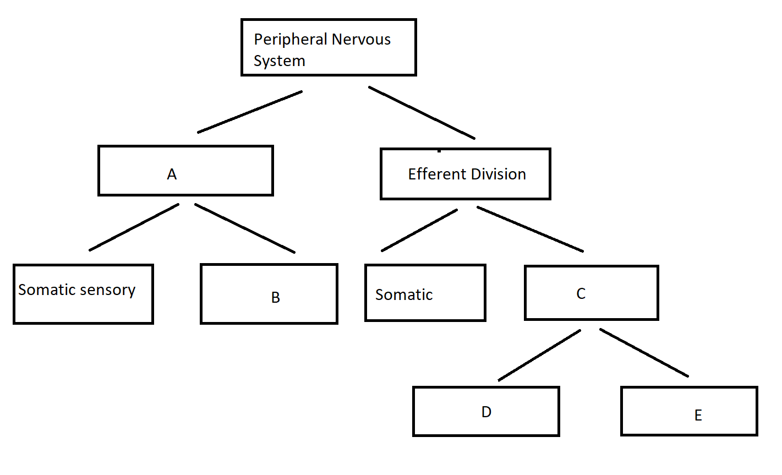**

1. Give the name for each division represented by the letters in the image above. (5 marks)

A:\_\_\_\_\_\_\_\_\_\_\_\_\_\_\_\_\_\_\_\_\_\_\_\_\_\_\_\_\_\_\_\_\_\_\_\_\_\_\_\_\_\_\_\_\_\_\_\_\_\_\_\_\_\_\_\_\_\_\_\_\_\_\_\_\_\_B:\_\_\_\_\_\_\_\_\_\_\_\_\_\_\_\_\_\_\_\_\_\_\_\_\_\_\_\_\_\_\_\_\_\_\_\_\_\_\_\_\_\_\_\_\_\_\_\_\_\_\_\_\_\_\_\_\_\_\_\_\_\_\_\_\_\_C:\_\_\_\_\_\_\_\_\_\_\_\_\_\_\_\_\_\_\_\_\_\_\_\_\_\_\_\_\_\_\_\_\_\_\_\_\_\_\_\_\_\_\_\_\_\_\_\_\_\_\_\_\_\_\_\_\_\_\_\_\_\_\_\_\_\_D:\_\_\_\_\_\_\_\_\_\_\_\_\_\_\_\_\_\_\_\_\_\_\_\_\_\_\_\_\_\_\_\_\_\_\_\_\_\_\_\_\_\_\_\_\_\_\_\_\_\_\_\_\_\_\_\_\_\_\_\_\_\_\_\_\_\_E:\_\_\_\_\_\_\_\_\_\_\_\_\_\_\_\_\_\_\_\_\_\_\_\_\_\_\_\_\_\_\_\_\_\_\_\_\_\_\_\_\_\_\_\_\_\_\_\_\_\_\_\_\_\_\_\_\_\_\_\_\_\_\_\_\_\_

1. Describe any **two** effects on the body when D and E are activated.

(4 marks)

D:\_\_\_\_\_\_\_\_\_\_\_\_\_\_\_\_\_\_\_\_\_\_\_\_\_\_\_\_\_\_\_\_\_\_\_\_\_\_\_\_\_\_\_\_\_\_\_\_\_\_\_\_\_\_\_\_\_\_\_\_\_\_\_\_\_\_\_\_\_\_\_\_\_\_\_\_\_\_\_\_\_\_\_\_\_\_\_\_\_\_\_\_\_\_\_\_\_\_\_\_\_\_\_\_\_\_\_\_\_\_\_\_\_\_\_\_\_\_\_\_\_\_\_\_\_\_\_\_\_\_\_\_\_

\_\_\_\_\_\_\_\_\_\_\_\_\_\_\_\_\_\_\_\_\_\_\_\_\_\_\_\_\_\_\_\_\_\_\_\_\_\_\_\_\_\_\_\_\_\_\_\_\_\_\_\_\_\_\_\_\_\_\_\_\_\_\_\_\_\_\_

E:\_\_\_\_\_\_\_\_\_\_\_\_\_\_\_\_\_\_\_\_\_\_\_\_\_\_\_\_\_\_\_\_\_\_\_\_\_\_\_\_\_\_\_\_\_\_\_\_\_\_\_\_\_\_\_\_\_\_\_\_\_\_\_\_\_\_\_\_\_\_\_\_\_\_\_\_\_\_\_\_\_\_\_\_\_\_\_\_\_\_\_\_\_\_\_\_\_\_\_\_\_\_\_\_\_\_\_\_\_\_\_\_\_\_\_\_\_\_\_\_\_\_\_\_\_\_\_\_\_\_\_\_\_\_\_\_\_\_\_\_\_\_\_\_\_\_\_\_\_\_\_\_\_\_\_\_\_\_\_\_\_\_\_\_\_\_\_\_\_\_\_\_\_\_\_\_\_\_\_\_\_\_\_\_\_\_\_\_\_\_\_\_\_\_\_\_\_\_\_\_

**Question 33 (11 marks)**

1. Inflammation is the body’s response to an invading pathogen. In the table below outline the role of each substance listed in the inflammatory response.

(3 marks)

|  |  |
| --- | --- |
|  | **Role in the inflammatory response** |
| Histamine |  |
| Heparin |  |
| Phagocytes |  |

The diagram below represents a particular action of antibodies on E. coli.

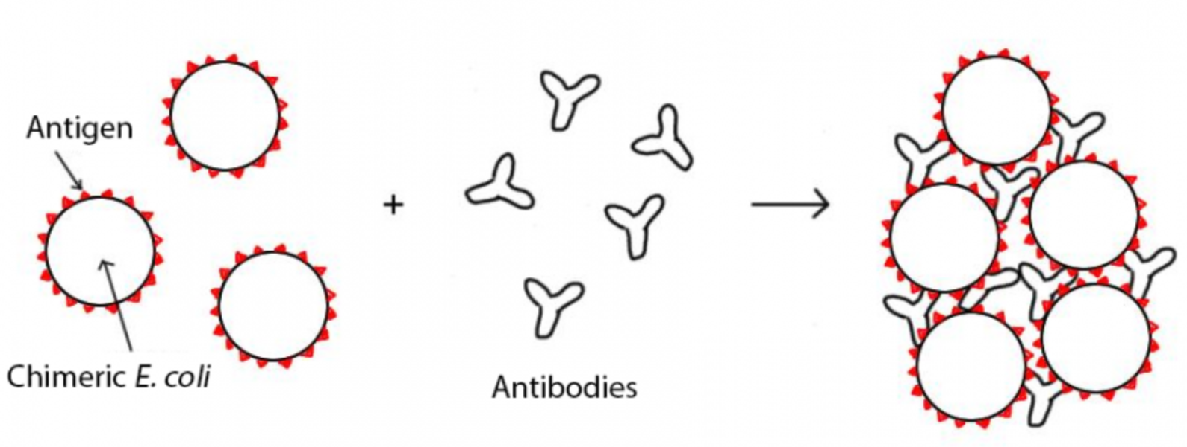

1. Name this action of antibodies. (1 mark)

\_\_\_\_\_\_\_\_\_\_\_\_\_\_\_\_\_\_\_\_\_\_\_\_\_\_\_\_\_\_\_\_\_\_\_\_\_\_\_\_\_\_\_\_\_\_\_\_\_\_\_\_\_\_\_\_\_\_\_\_\_\_\_\_\_\_\_

1. Describe **three** other ways antibodies can act on pathogens.

(3 marks)

One:\_\_\_\_\_\_\_\_\_\_\_\_\_\_\_\_\_\_\_\_\_\_\_\_\_\_\_\_\_\_\_\_\_\_\_\_\_\_\_\_\_\_\_\_\_\_\_\_\_\_\_\_\_\_\_\_\_\_\_\_\_\_\_\_\_\_\_\_\_\_\_\_\_\_\_\_\_\_\_\_\_\_\_\_\_\_\_\_\_\_\_\_\_\_\_\_\_\_\_\_\_\_\_\_\_\_\_\_\_\_\_\_\_\_\_\_\_\_\_\_\_\_\_\_\_\_\_\_\_\_ Two:\_\_\_\_\_\_\_\_\_\_\_\_\_\_\_\_\_\_\_\_\_\_\_\_\_\_\_\_\_\_\_\_\_\_\_\_\_\_\_\_\_\_\_\_\_\_\_\_\_\_\_\_\_\_\_\_\_\_\_\_\_\_\_\_\_\_\_\_\_\_\_\_\_\_\_\_\_\_\_\_\_\_\_\_\_\_\_\_\_\_\_\_\_\_\_\_\_\_\_\_\_\_\_\_\_\_\_\_\_\_\_\_\_\_\_\_\_\_\_\_\_\_\_\_\_\_\_\_\_\_ Three:\_\_\_\_\_\_\_\_\_\_\_\_\_\_\_\_\_\_\_\_\_\_\_\_\_\_\_\_\_\_\_\_\_\_\_\_\_\_\_\_\_\_\_\_\_\_\_\_\_\_\_\_\_\_\_\_\_\_\_\_\_\_\_\_\_\_\_\_\_\_\_\_\_\_\_\_\_\_\_\_\_\_\_\_\_\_\_\_\_\_\_\_\_\_\_\_\_\_\_\_\_\_\_\_\_\_\_\_\_\_\_\_\_\_\_\_\_\_\_\_\_\_\_\_\_\_\_\_\_

Whooping cough is a disease that has had a huge increase in cases in the past decade. School aged children are being encouraged to be vaccinated against this pathogen. A student received the vaccine and then three months later was exposed to the whooping cough pathogen.

1. On the axes below, draw and clearly label the antibody response for a student when they received the vaccine and when they were subsequently exposed to the pathogen. (4 marks)

Antibodies

Time

**Question 34 (11 marks)**

The diagram below shows the development of different vertebrate species.

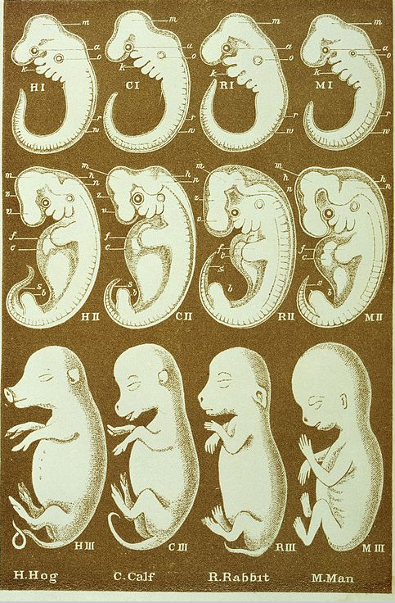

1. What is the name of this comparative study of evolution called? Describe how it provides evidence for evolution. (3 marks)

\_\_\_\_\_\_\_\_\_\_\_\_\_\_\_\_\_\_\_\_\_\_\_\_\_\_\_\_\_\_\_\_\_\_\_\_\_\_\_\_\_\_\_\_\_\_\_\_\_\_\_\_\_\_\_\_\_\_\_\_\_\_\_\_\_\_\_\_\_\_\_\_\_\_\_\_\_\_\_\_\_\_\_\_\_\_\_\_\_\_\_\_\_\_\_\_\_\_\_\_\_\_\_\_\_\_\_\_\_\_\_\_\_\_\_\_\_\_\_\_\_\_\_\_\_\_\_\_\_\_\_\_\_\_\_\_\_\_\_\_\_\_\_\_\_\_\_\_\_\_\_\_\_\_\_\_\_\_\_\_\_\_\_\_\_\_\_\_\_\_\_\_\_\_\_\_\_\_\_\_\_\_\_\_\_\_\_\_\_\_\_\_\_\_\_\_\_\_\_\_\_\_\_\_\_\_\_\_\_\_\_\_\_\_\_\_\_\_\_\_\_\_\_\_\_\_\_\_\_\_\_\_\_\_\_\_\_\_\_\_\_\_\_\_\_\_\_\_\_\_\_\_\_\_\_\_\_\_\_\_\_\_\_\_\_\_\_\_\_\_\_\_\_\_\_\_\_\_\_\_\_\_\_\_\_\_\_\_\_\_\_\_\_\_\_\_\_\_\_\_\_\_\_\_\_\_\_\_\_\_\_\_\_\_\_\_\_\_\_\_\_\_\_\_\_\_\_\_\_\_\_\_\_\_\_\_\_\_\_\_\_\_\_\_\_\_\_\_\_\_\_\_\_\_\_\_\_\_\_\_\_\_\_\_\_\_\_\_\_\_\_\_\_\_\_\_\_\_\_\_\_\_\_\_\_\_\_\_\_\_\_\_\_\_\_\_\_\_\_\_\_\_

1. Vestigial organs also provide evidence for evolution. Name **one** vestigial organ in humans and describe how it provides evidence for evolution. (2 marks)

\_\_\_\_\_\_\_\_\_\_\_\_\_\_\_\_\_\_\_\_\_\_\_\_\_\_\_\_\_\_\_\_\_\_\_\_\_\_\_\_\_\_\_\_\_\_\_\_\_\_\_\_\_\_\_\_\_\_\_\_\_\_\_\_\_\_\_\_\_\_\_\_\_\_\_\_\_\_\_\_\_\_\_\_\_\_\_\_\_\_\_\_\_\_\_\_\_\_\_\_\_\_\_\_\_\_\_\_\_\_\_\_\_\_\_\_\_\_\_\_\_\_\_\_\_\_\_\_\_\_\_\_\_\_\_\_\_\_\_\_\_\_\_\_\_\_\_\_\_\_\_\_\_\_\_\_\_\_\_\_\_\_\_\_\_\_\_\_\_\_\_\_\_\_\_\_\_\_\_\_\_\_\_\_\_\_\_\_\_\_\_\_\_\_\_\_\_\_\_\_\_\_\_\_\_\_\_\_\_\_\_\_\_\_\_\_\_\_\_\_\_\_\_\_\_\_\_\_\_\_\_\_\_\_\_\_\_\_\_\_\_\_\_\_\_\_\_\_\_\_\_\_\_\_\_\_\_\_\_\_\_\_\_\_\_\_\_\_

A new primate species was found deep in the jungle that had similar morphology to many of the great apes that still exist today, as well as some extinct species. Scientists studying this primate were debating whether to use comparative studies of biochemistry or comparative genomics. The scientists wanted to be as accurate as possible when determining the relatedness of the new species to known species.

1. Which method would you recommend the scientist use and why?

(2 marks)

\_\_\_\_\_\_\_\_\_\_\_\_\_\_\_\_\_\_\_\_\_\_\_\_\_\_\_\_\_\_\_\_\_\_\_\_\_\_\_\_\_\_\_\_\_\_\_\_\_\_\_\_\_\_\_\_\_\_\_\_\_\_\_\_\_\_\_\_\_\_\_\_\_\_\_\_\_\_\_\_\_\_\_\_\_\_\_\_\_\_\_\_\_\_\_\_\_\_\_\_\_\_\_\_\_\_\_\_\_\_\_\_\_\_\_\_\_\_\_\_\_\_\_\_\_\_\_\_\_\_\_\_\_\_\_\_\_\_\_\_\_\_\_\_\_\_\_\_\_\_\_\_\_\_\_\_\_\_\_\_\_\_\_\_\_\_\_\_\_\_\_\_\_\_\_\_\_\_\_\_\_\_\_\_\_\_\_\_\_\_\_\_\_\_\_\_\_\_\_\_\_

The new primate species was found in the same area in Borneo as the Bornean Orang Utan, and was determined to have a common ancestor with this species.

1. Describe the likely process the newly discovered primate and the Bornean Orang Utan underwent to become two distinct species. (4 marks)

\_\_\_\_\_\_\_\_\_\_\_\_\_\_\_\_\_\_\_\_\_\_\_\_\_\_\_\_\_\_\_\_\_\_\_\_\_\_\_\_\_\_\_\_\_\_\_\_\_\_\_\_\_\_\_\_\_\_\_\_\_\_\_\_\_\_\_\_\_\_\_\_\_\_\_\_\_\_\_\_\_\_\_\_\_\_\_\_\_\_\_\_\_\_\_\_\_\_\_\_\_\_\_\_\_\_\_\_\_\_\_\_\_\_\_\_\_\_\_\_\_\_\_\_\_\_\_\_\_\_\_\_\_\_\_\_\_\_\_\_\_\_\_\_\_\_\_\_\_\_\_\_\_\_\_\_\_\_\_\_\_\_\_\_\_\_\_\_\_\_\_\_\_\_\_\_\_\_\_\_\_\_\_\_\_\_\_\_\_\_\_\_\_\_\_\_\_\_\_\_\_\_\_\_\_\_\_\_\_\_\_\_\_\_\_\_\_\_\_\_\_\_\_\_\_\_\_\_\_\_\_\_\_\_\_\_\_\_\_\_\_\_\_\_\_\_\_\_\_\_\_\_\_\_\_\_\_\_\_\_\_\_\_\_\_\_\_\_\_\_\_\_\_\_\_\_\_\_\_\_\_\_\_\_\_\_\_\_\_\_\_\_\_\_\_\_\_\_\_\_\_\_\_\_\_\_\_\_\_\_\_\_\_\_\_\_\_\_\_\_\_\_\_\_\_\_\_\_\_\_\_\_\_\_\_\_\_\_\_\_\_\_\_\_\_\_\_\_\_\_\_\_\_\_\_\_\_\_\_\_\_\_\_\_\_\_\_\_\_\_\_\_\_\_\_\_\_\_\_\_\_\_\_\_\_\_\_\_\_\_\_\_\_\_\_\_\_\_\_\_\_\_\_\_\_\_\_\_\_\_\_\_\_\_\_\_\_\_\_\_\_\_\_\_\_\_\_\_\_\_\_\_\_\_\_\_\_\_\_\_\_\_\_\_\_\_\_\_\_\_\_\_\_\_\_\_\_\_\_\_\_\_\_\_\_\_\_\_\_\_\_\_\_\_\_\_\_\_\_\_\_\_\_\_\_\_\_\_\_\_\_\_\_\_\_\_\_\_\_\_\_\_\_\_\_\_\_\_\_\_\_\_\_\_\_\_\_\_\_\_\_\_\_\_\_\_\_\_\_\_\_\_\_\_\_\_\_\_\_\_\_\_\_\_\_\_\_\_\_\_\_\_\_\_\_\_\_\_\_\_\_\_\_\_\_\_\_\_\_\_\_\_\_\_\_\_\_\_\_\_\_\_\_\_\_\_\_\_\_\_\_\_\_\_\_\_\_\_\_\_\_\_\_

**Question 35 (14 marks)**

Human mitochondrial DNA (mtDNA) contains 37 genes, all of which are involved in protein synthesis and cellular respiration. Comparison of mitochondrial DNA has allowed scientists to track differences in mtDNA sequences between human groups to show migration patterns around the world of our original ancestors. These differences in sequences are due to mutations.

1. What is a mutation? (1 mark)

\_\_\_\_\_\_\_\_\_\_\_\_\_\_\_\_\_\_\_\_\_\_\_\_\_\_\_\_\_\_\_\_\_\_\_\_\_\_\_\_\_\_\_\_\_\_\_\_\_\_\_\_\_\_\_\_\_\_\_\_\_\_\_\_\_\_\_\_\_\_\_\_\_\_\_\_\_\_\_\_\_\_\_\_\_\_\_\_\_\_\_\_\_\_\_\_\_\_\_\_\_\_\_\_\_\_\_\_\_\_\_\_\_\_\_\_\_\_\_\_\_\_\_\_\_\_\_\_\_\_\_\_\_\_

1. Name **two** environmental factors that can give rise to mutation.(2 marks)

\_\_\_\_\_\_\_\_\_\_\_\_\_\_\_\_\_\_\_\_\_\_\_\_\_\_\_\_\_\_\_\_\_\_\_\_\_\_\_\_\_\_\_\_\_\_\_\_\_\_\_\_\_\_\_\_\_\_\_\_\_\_\_\_\_\_\_\_\_\_\_\_\_\_\_\_\_\_\_\_\_\_\_\_\_\_\_\_\_\_\_\_\_\_\_\_\_\_\_\_\_\_\_\_\_\_\_\_\_\_\_\_\_\_\_\_\_\_\_\_\_\_\_\_\_\_\_\_\_\_\_\_\_\_

1. How is mitochondrial DNA inherited? Why does this feature make it suitable for tracking human movement over time? (3 marks)

\_\_\_\_\_\_\_\_\_\_\_\_\_\_\_\_\_\_\_\_\_\_\_\_\_\_\_\_\_\_\_\_\_\_\_\_\_\_\_\_\_\_\_\_\_\_\_\_\_\_\_\_\_\_\_\_\_\_\_\_\_\_\_\_\_\_\_\_\_\_\_\_\_\_\_\_\_\_\_\_\_\_\_\_\_\_\_\_\_\_\_\_\_\_\_\_\_\_\_\_\_\_\_\_\_\_\_\_\_\_\_\_\_\_\_\_\_\_\_\_\_\_\_\_\_\_\_\_\_\_\_\_\_\_\_\_\_\_\_\_\_\_\_\_\_\_\_\_\_\_\_\_\_\_\_\_\_\_\_\_\_\_\_\_\_\_\_\_\_\_\_\_\_\_\_\_\_\_\_\_\_\_\_\_\_\_\_\_\_\_\_\_\_\_\_\_\_\_\_\_\_\_\_\_\_\_\_\_\_\_\_\_\_\_\_\_\_\_\_\_\_\_\_\_\_\_\_\_\_\_\_\_\_\_\_\_\_\_\_\_\_\_\_\_\_\_\_\_\_\_\_\_\_\_\_\_\_\_\_\_\_\_\_\_\_\_\_\_

Nuclear DNA is also prone to mutation. These mutations can be somatic or germline.

1. Describe **two** possible consequences of acquiring a somatic mutation. (4 marks)

\_\_\_\_\_\_\_\_\_\_\_\_\_\_\_\_\_\_\_\_\_\_\_\_\_\_\_\_\_\_\_\_\_\_\_\_\_\_\_\_\_\_\_\_\_\_\_\_\_\_\_\_\_\_\_\_\_\_\_\_\_\_\_\_\_\_\_\_\_\_\_\_\_\_\_\_\_\_\_\_\_\_\_\_\_\_\_\_\_\_\_\_\_\_\_\_\_\_\_\_\_\_\_\_\_\_\_\_\_\_\_\_\_\_\_\_\_\_\_\_\_\_\_\_\_\_\_\_\_\_\_\_\_\_\_\_\_\_\_\_\_\_\_\_\_\_\_\_\_\_\_\_\_\_\_\_\_\_\_\_\_\_\_\_\_\_\_\_\_\_\_\_\_\_\_\_\_\_\_\_\_\_\_\_\_\_\_\_\_\_\_\_\_\_\_\_\_\_\_\_\_\_\_\_\_\_\_\_\_\_\_\_\_\_\_\_\_\_\_\_\_\_\_\_\_\_\_\_\_\_\_\_\_\_\_\_\_\_\_\_\_\_\_\_\_\_\_\_\_\_\_\_\_\_\_\_\_\_\_\_\_\_\_\_\_\_\_\_

1. Describe the relationship between mutations and the change in gene pools over time due to natural selection.

(4 marks)

\_\_\_\_\_\_\_\_\_\_\_\_\_\_\_\_\_\_\_\_\_\_\_\_\_\_\_\_\_\_\_\_\_\_\_\_\_\_\_\_\_\_\_\_\_\_\_\_\_\_\_\_\_\_\_\_\_\_\_\_\_\_\_\_\_\_\_\_\_\_\_\_\_\_\_\_\_\_\_\_\_\_\_\_\_\_\_\_\_\_\_\_\_\_\_\_\_\_\_\_\_\_\_\_\_\_\_\_\_\_\_\_\_\_\_\_\_\_\_\_\_\_\_\_\_\_\_\_\_\_\_\_\_\_\_\_\_\_\_\_\_\_\_\_\_\_\_\_\_\_\_\_\_\_\_\_\_\_\_\_\_\_\_\_\_\_\_\_\_\_\_\_\_\_\_\_\_\_\_\_\_\_\_\_\_\_\_\_\_\_\_\_\_\_\_\_\_\_\_\_\_\_\_\_\_\_\_\_\_\_\_\_\_\_\_\_\_\_\_\_\_\_\_\_\_\_\_\_\_\_\_\_\_\_\_\_\_\_\_\_\_\_\_\_\_\_\_\_\_\_\_\_\_\_\_\_\_\_\_\_\_\_\_\_\_\_\_\_\_\_\_\_\_\_\_\_\_\_\_\_\_\_\_\_\_\_\_\_\_\_\_\_\_\_\_\_\_\_\_\_\_\_\_\_\_\_\_\_\_\_\_\_\_\_\_\_\_\_\_\_\_\_\_\_\_\_\_\_\_\_\_\_\_\_\_\_\_\_\_\_\_\_\_\_\_\_\_\_\_\_\_\_\_\_\_\_\_\_\_\_\_\_\_\_\_\_\_\_\_\_\_\_\_\_\_\_\_\_\_\_\_\_\_\_\_\_\_\_\_\_\_\_\_\_\_\_\_\_\_\_\_\_\_\_\_\_\_\_\_\_\_\_\_\_\_\_\_\_\_\_\_\_\_\_\_\_\_\_\_\_\_\_\_\_\_\_\_\_\_\_\_\_\_\_\_\_\_\_\_\_\_\_\_\_\_\_\_\_\_\_\_\_\_\_\_\_\_\_\_\_\_\_\_\_\_\_\_\_\_\_\_\_\_\_\_\_\_\_\_\_\_\_\_\_\_\_\_\_\_\_\_\_\_\_\_\_\_\_\_\_\_\_\_\_\_\_\_\_\_\_\_\_\_\_\_\_\_\_\_\_\_\_\_\_\_\_

**Question 36 (11 marks)**

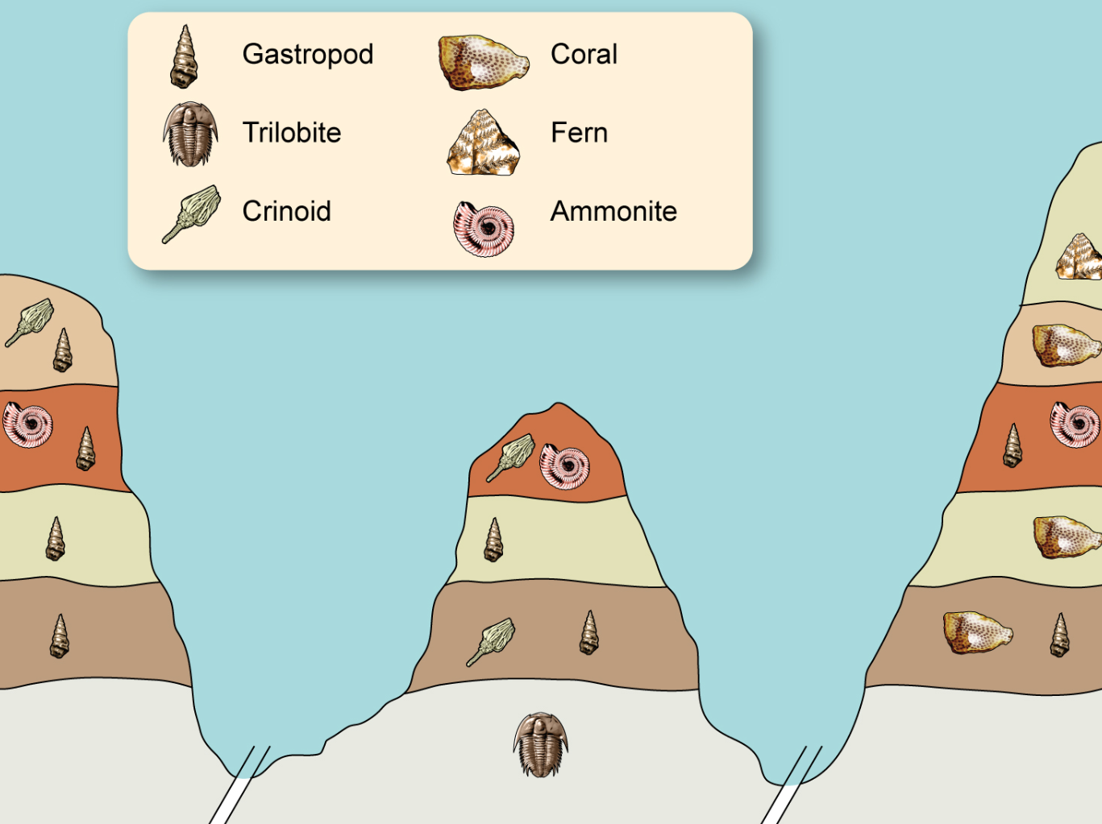

1. Which is the most recently evolved fossil out of the ammonite and crinoid? Provide a reason for your choice. (2 marks)

\_\_\_\_\_\_\_\_\_\_\_\_\_\_\_\_\_\_\_\_\_\_\_\_\_\_\_\_\_\_\_\_\_\_\_\_\_\_\_\_\_\_\_\_\_\_\_\_\_\_\_\_\_\_\_\_\_\_\_\_\_\_\_\_\_\_\_\_\_\_\_\_\_\_\_\_\_\_\_\_\_\_\_\_\_\_\_\_\_\_\_\_\_\_\_\_\_\_\_\_\_\_\_\_\_\_\_\_\_\_\_\_\_\_\_\_\_\_\_\_\_\_\_\_\_\_\_\_\_\_\_\_\_\_\_\_\_\_\_\_\_\_\_\_\_\_\_\_\_\_\_\_\_\_\_\_\_\_\_\_\_\_\_\_\_\_\_\_\_\_\_\_\_\_\_\_\_\_\_\_\_\_\_\_\_\_\_\_\_\_\_\_\_\_\_\_\_\_\_\_\_

1. Explain whether the gastropod would be a suitable organism to be used as an index fossil. (2 marks)

\_\_\_\_\_\_\_\_\_\_\_\_\_\_\_\_\_\_\_\_\_\_\_\_\_\_\_\_\_\_\_\_\_\_\_\_\_\_\_\_\_\_\_\_\_\_\_\_\_\_\_\_\_\_\_\_\_\_\_\_\_\_\_\_\_\_\_\_\_\_\_\_\_\_\_\_\_\_\_\_\_\_\_\_\_\_\_\_\_\_\_\_\_\_\_\_\_\_\_\_\_\_\_\_\_\_\_\_\_\_\_\_\_\_\_\_\_\_\_\_\_\_\_\_\_\_\_\_\_\_\_\_\_\_\_\_\_\_\_\_\_\_\_\_\_\_\_\_\_\_\_\_\_\_\_\_\_\_\_\_\_\_\_\_\_\_\_\_\_\_\_\_\_\_\_\_\_\_\_\_\_\_\_\_\_\_\_\_\_\_\_\_\_\_\_\_\_\_\_\_\_

1. What is absolute dating? Name **two** different types of absolute dating and for each identify the object that is tested and the age range for the object. (7 marks)

\_\_\_\_\_\_\_\_\_\_\_\_\_\_\_\_\_\_\_\_\_\_\_\_\_\_\_\_\_\_\_\_\_\_\_\_\_\_\_\_\_\_\_\_\_\_\_\_\_\_\_\_\_\_\_\_\_\_\_\_\_\_\_\_\_\_\_\_\_\_\_\_\_\_\_\_\_\_\_\_\_\_\_\_\_\_\_\_\_\_\_\_\_\_\_\_\_\_\_\_\_\_\_\_\_\_\_\_\_\_\_\_\_\_\_\_\_\_\_\_\_\_\_\_\_\_\_\_\_\_\_\_\_\_\_\_\_\_\_\_\_\_\_\_\_\_\_\_\_\_\_\_\_\_\_\_\_\_\_\_\_\_\_\_\_\_\_\_\_\_\_\_\_\_\_\_\_\_\_\_\_\_\_\_\_\_\_\_\_\_\_\_\_\_\_\_\_\_\_\_\_\_\_\_\_\_\_\_\_\_\_\_\_\_\_\_\_\_\_\_\_\_\_\_\_\_\_\_\_\_\_\_\_\_\_\_\_\_\_\_\_\_\_\_\_\_\_\_\_\_\_\_\_\_\_\_\_\_\_\_\_\_\_\_\_\_\_\_\_\_\_\_\_\_\_\_\_\_\_\_\_\_\_\_\_\_\_\_\_\_\_\_\_\_\_\_\_\_\_\_\_\_\_\_\_\_\_\_\_\_\_\_\_\_\_\_\_\_\_\_\_\_\_\_\_\_\_\_\_\_\_\_\_\_\_\_\_\_\_\_\_\_\_\_\_\_\_\_\_\_\_\_\_\_\_\_\_\_\_\_\_\_\_\_\_\_\_\_\_\_\_\_\_\_\_\_\_\_\_\_\_\_\_\_\_\_\_\_\_\_\_\_\_\_\_\_\_\_\_\_\_\_\_\_\_\_\_\_\_\_\_\_\_\_\_\_\_\_\_\_\_\_\_\_\_\_\_\_\_\_\_\_\_\_\_\_\_\_\_\_\_\_\_\_\_\_\_\_\_\_\_\_\_\_\_\_\_\_\_\_\_\_\_\_\_\_\_\_\_\_\_\_\_\_\_\_\_\_\_\_\_\_\_\_\_\_\_\_\_\_\_\_\_\_\_\_\_\_\_\_\_\_\_\_\_\_\_\_\_\_\_\_\_\_\_\_\_\_\_\_\_\_\_\_\_\_\_\_\_\_\_\_\_\_\_\_\_\_\_\_\_\_\_\_\_\_\_\_\_\_\_\_\_\_\_\_\_\_\_\_\_\_\_\_\_\_\_\_\_\_\_\_\_\_\_\_\_\_\_\_\_\_\_\_\_\_\_\_\_\_\_\_\_\_\_\_\_\_\_\_\_\_\_\_\_\_\_\_\_\_\_\_\_\_\_\_\_\_\_\_\_\_\_\_\_\_\_\_\_\_\_\_\_\_\_\_\_\_\_\_\_\_\_\_\_\_\_\_\_\_\_\_\_\_\_\_\_\_\_\_\_\_\_\_\_\_\_\_\_\_\_\_\_\_\_\_\_\_\_\_\_\_\_\_\_\_\_\_\_\_\_\_\_\_\_\_\_\_\_\_\_\_\_\_\_\_\_\_\_\_\_\_\_\_\_\_\_\_\_\_\_\_\_\_\_\_\_\_\_\_\_\_\_\_\_\_\_

**Question 37 (18 marks)**

The diagram below shows the glands of the endocrine system.

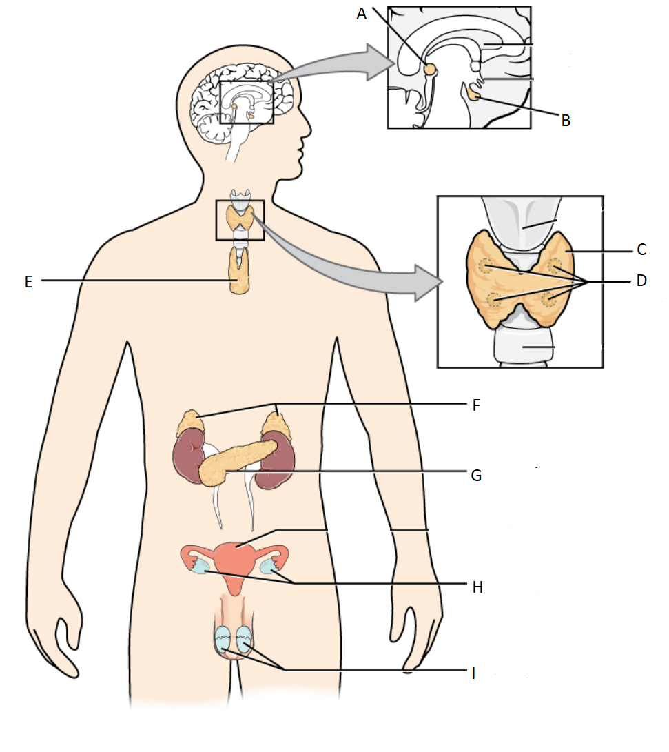

1. Name the endocrine organ and give an example of **one** hormone it produces. (6 marks)

C:\_\_\_\_\_\_\_\_\_\_\_\_\_\_\_\_\_\_\_\_\_\_\_\_\_\_\_\_\_\_\_\_\_\_\_\_\_\_\_\_\_\_\_\_\_\_\_\_\_\_\_\_\_\_\_\_\_\_\_\_\_\_\_\_\_\_\_\_\_\_\_\_\_\_\_\_\_\_\_\_\_\_\_\_\_\_\_\_\_\_\_\_\_\_\_\_\_\_\_\_\_\_\_\_\_\_\_\_\_\_\_\_\_\_\_\_\_\_\_\_\_\_\_\_\_\_\_\_\_\_\_\_\_ D:\_\_\_\_\_\_\_\_\_\_\_\_\_\_\_\_\_\_\_\_\_\_\_\_\_\_\_\_\_\_\_\_\_\_\_\_\_\_\_\_\_\_\_\_\_\_\_\_\_\_\_\_\_\_\_\_\_\_\_\_\_\_\_\_\_\_\_\_\_\_\_\_\_\_\_\_\_\_\_\_\_\_\_\_\_\_\_\_\_\_\_\_\_\_\_\_\_\_\_\_\_\_\_\_\_\_\_\_\_\_\_\_\_\_\_\_\_\_\_\_\_\_\_\_\_\_\_\_\_\_\_\_\_G:\_\_\_\_\_\_\_\_\_\_\_\_\_\_\_\_\_\_\_\_\_\_\_\_\_\_\_\_\_\_\_\_\_\_\_\_\_\_\_\_\_\_\_\_\_\_\_\_\_\_\_\_\_\_\_\_\_\_\_\_\_\_\_\_\_\_\_\_\_\_\_\_\_\_\_\_\_\_\_\_\_\_\_\_\_\_\_\_\_\_\_\_\_\_\_\_\_\_\_\_\_\_\_\_\_\_\_\_\_\_\_\_\_\_\_\_\_\_\_\_\_\_\_\_\_\_\_\_\_\_\_\_

1. Cortisol and glucagon are both hormones that work to increase the levels of glucose in the blood. However, they differ in their mode of action. Cortisol is a lipid soluble hormone and glucagon is a water-soluble hormone. In the table below contrast the mode of action of these two hormones. (6 marks)

|  |  |
| --- | --- |
| Cortisol | Glucagon |
|  |  |

1. Hypothyroidism is a disorder of the endocrine system. State **two** possible causes, **two** likely symptoms and **two** methods that could be used to treat the symptoms of this disorder. (6 marks)

\_\_\_\_\_\_\_\_\_\_\_\_\_\_\_\_\_\_\_\_\_\_\_\_\_\_\_\_\_\_\_\_\_\_\_\_\_\_\_\_\_\_\_\_\_\_\_\_\_\_\_\_\_\_\_\_\_\_\_\_\_\_\_\_\_\_\_\_\_\_\_\_\_\_\_\_\_\_\_\_\_\_\_\_\_\_\_\_\_\_\_\_\_\_\_\_\_\_\_\_\_\_\_\_\_\_\_\_\_\_\_\_\_\_\_\_\_\_\_\_\_\_\_\_\_\_\_\_\_\_\_\_\_\_\_\_\_\_\_\_\_\_\_\_\_\_\_\_\_\_\_\_\_\_\_\_\_\_\_\_\_\_\_\_\_\_\_\_\_\_\_\_\_\_\_\_\_\_\_\_\_\_\_\_\_\_\_\_\_\_\_\_\_\_\_\_\_\_\_\_\_\_\_\_\_\_\_\_\_\_\_\_\_\_\_\_\_\_\_\_\_\_\_\_\_\_\_\_\_\_\_\_\_\_\_\_\_\_\_\_\_\_\_\_\_\_\_\_\_\_\_\_\_\_\_\_\_\_\_\_\_\_\_\_\_\_\_\_\_\_\_\_\_\_\_\_\_\_\_\_\_\_\_\_\_\_\_\_\_\_\_\_\_\_\_\_\_\_\_\_\_\_\_\_\_\_\_\_\_\_\_\_\_\_\_\_\_\_\_\_\_\_\_\_\_\_\_\_\_\_\_\_\_\_\_\_\_\_\_\_\_\_\_\_\_\_\_\_\_\_\_\_\_\_\_\_\_\_\_\_\_\_\_\_\_\_\_\_\_\_\_\_\_\_\_\_\_\_\_\_\_\_\_\_\_\_\_\_\_\_\_\_\_\_\_\_\_\_\_\_\_\_\_\_\_\_\_\_\_\_\_\_\_\_\_\_\_\_\_\_\_\_\_\_\_\_\_\_\_\_\_\_\_\_\_\_\_\_\_\_\_\_\_\_\_\_\_\_\_\_\_\_\_\_\_\_\_\_\_\_\_\_\_\_\_\_\_\_\_\_\_\_\_\_\_\_\_\_\_\_\_\_\_\_\_\_\_\_\_\_\_\_\_\_\_\_\_\_\_\_\_\_\_\_\_\_\_\_\_\_\_\_\_\_\_\_\_\_\_\_\_\_\_\_\_\_\_\_\_\_\_\_\_\_\_\_\_\_\_\_\_\_\_\_\_\_\_\_\_\_\_\_\_\_\_\_\_\_\_\_\_\_\_\_\_\_\_\_\_\_\_\_\_\_\_\_\_\_\_\_\_\_\_\_\_\_\_\_\_\_\_\_\_\_\_\_\_\_\_\_\_\_\_\_\_\_\_\_\_\_\_\_\_\_\_\_\_\_\_\_\_\_\_\_\_\_\_\_\_\_\_\_\_\_\_\_\_\_\_\_\_\_\_\_\_\_\_\_\_\_\_\_\_\_\_\_\_\_\_\_\_\_\_\_\_\_\_\_\_\_

**Question 38 (10 marks)**

In March 2019 in Hubei Province, China, thousands of fossils washed up on a beach. These fossils were a particularly unusual find because they were soft-bodied organisms including many species of jellyfish, sea anemones and algae and much of their soft tissue was preserved.

1. In the table below compare and contrast the conditions required for the fossilisation of soft-tissue compared with hard tissue, such as teeth and bone. (3 marks)

|  |  |  |
| --- | --- | --- |
|  | **Soft-tissue** | **Hard tissue** |
| Compare |  | |
| Contrast |  |  |

1. What **four** conditions are usually required for a fossil to form?(4 marks)

\_\_\_\_\_\_\_\_\_\_\_\_\_\_\_\_\_\_\_\_\_\_\_\_\_\_\_\_\_\_\_\_\_\_\_\_\_\_\_\_\_\_\_\_\_\_\_\_\_\_\_\_\_\_\_\_\_\_\_\_\_\_\_\_\_\_\_\_\_\_\_\_\_\_\_\_\_\_\_\_\_\_\_\_\_\_\_\_\_\_\_\_\_\_\_\_\_\_\_\_\_\_\_\_\_\_\_\_\_\_\_\_\_\_\_\_\_\_\_\_\_\_\_\_\_\_\_\_\_\_\_\_\_\_\_\_\_\_\_\_\_\_\_\_\_\_\_\_\_\_\_\_\_\_\_\_\_\_\_\_\_\_\_\_\_\_\_\_\_\_\_\_\_\_\_\_\_\_\_\_\_\_\_\_\_\_\_\_\_\_\_\_\_\_\_\_\_\_\_\_\_\_\_\_\_\_\_\_\_\_\_\_\_\_\_\_\_\_\_\_\_\_\_\_\_\_\_\_\_\_\_\_\_\_\_\_\_\_\_\_\_\_\_\_\_\_\_\_\_\_\_\_\_\_\_\_\_\_\_\_\_\_\_\_\_\_\_\_\_\_\_\_\_\_\_\_\_\_\_\_\_\_\_\_\_\_\_\_\_\_\_\_\_\_\_\_\_\_\_\_\_\_\_\_\_\_\_\_\_\_\_\_\_\_\_\_\_\_\_\_\_\_\_\_\_\_\_\_\_\_\_\_\_\_\_\_\_\_\_\_\_\_\_\_\_\_\_\_\_\_\_\_\_\_\_\_\_\_\_\_\_\_\_\_\_\_\_\_\_\_\_\_\_\_\_\_\_\_\_\_\_\_\_\_\_\_\_\_\_\_\_\_\_\_\_\_\_\_\_\_\_\_\_\_\_\_\_\_\_\_\_\_\_\_\_\_\_\_\_\_\_\_\_\_\_\_\_\_\_\_\_\_\_\_\_\_\_\_\_\_\_\_\_\_\_\_\_\_\_\_\_\_\_\_\_\_\_\_\_\_\_\_\_\_\_\_\_\_\_

1. The fossil record is incomplete and does not account for all of the organisms that have existed. Describe **three** reasons for the incomplete nature of the fossil record. (3 marks)

\_\_\_\_\_\_\_\_\_\_\_\_\_\_\_\_\_\_\_\_\_\_\_\_\_\_\_\_\_\_\_\_\_\_\_\_\_\_\_\_\_\_\_\_\_\_\_\_\_\_\_\_\_\_\_\_\_\_\_\_\_\_\_\_\_\_\_\_\_\_\_\_\_\_\_\_\_\_\_\_\_\_\_\_\_\_\_\_\_\_\_\_\_\_\_\_\_\_\_\_\_\_\_\_\_\_\_\_\_\_\_\_\_\_\_\_\_\_\_\_\_\_\_\_\_\_\_\_\_\_\_\_\_\_\_\_\_\_\_\_\_\_\_\_\_\_\_\_\_\_\_\_\_\_\_\_\_\_\_\_\_\_\_\_\_\_\_\_\_\_\_\_\_\_\_\_\_\_\_\_\_\_\_\_\_\_\_\_\_\_\_\_\_\_\_\_\_\_\_\_\_\_\_\_\_\_\_\_\_\_\_\_\_\_\_\_\_\_\_\_\_\_\_\_\_\_\_\_\_\_\_\_\_\_\_\_\_\_\_\_\_\_\_\_\_\_\_\_\_\_\_\_\_\_\_\_\_\_\_\_\_\_\_\_\_\_\_\_\_\_\_\_\_\_\_\_\_\_\_\_\_\_\_\_\_\_\_\_\_\_\_\_\_\_\_\_\_\_\_\_\_\_\_\_\_\_\_\_\_\_\_\_\_\_\_\_\_\_\_\_\_\_\_\_\_\_\_\_\_\_\_\_\_\_\_

**Section Three: Extended answer 20% (40 Marks)**

This section contains **three** questions. You must answer **two (2)** questions. Write your answers on the pages following Question 41.

Supplementary pages for planning/continuing your answers to a question are provided at the end of this Question/Answer booklet. If you use these pages to continue an answer, indicate at the original answer where the answer is continued, i.e. give the page number.

Suggested working time: 50 minutes.

Answer any **two** questions from Questions 39 to 41.

Indicate the questions you will answer by ticking the box next to the question. Write your answers on pages that follow.

**Question 39 (20 marks)**

1. An evolutionary trend is a pattern of directional change that occurs in several species over a long period of time. Referring specifically to prognathism, size of brain case compared to body size, and dentition, describe the changes seen in the following Hominid species.

* *Paranthropus robustus*
* *Homo habilis*
* *Homo erectus*

(9 marks)

In 2015, palaeontologists uncovered fossilised remains of a new Hominid species *Homo naledi* in a complex cave network in South Africa. This species was identified to have legs and feet similar to *Homo sapiens* while having hands and a pelvis similar to *Australopithicus afarensis.* The *Homo naledi* specimens were dated as being between 36000 and 45000 years old.

1. Describe the features you would expect to see in the legs, feet, hands and pelvis of *Homo naledi*.

(8 marks)

1. Name the dating method that was used to assign an age to the *Homo naledi* specimens and explain why this method was used. (3 marks)

**Question 40 (20 marks)**

Susan and her mother Lesley are working in a basement fixing a leaking gas heater. The space is very small and poorly ventilated and, after a while, both of them notice an increase in the rate and depth of their breathing. As they noticed the increased respiratory rate, they have rushed up the stairs and opened windows until their breathing rates returned to normal.

1. Describe the homeostatic mechanism that caused the increased breathing rate in this situation. In your answer describe how the body detects and maintains gas concentrations in the blood. (12 marks)

The message to increase the rate and depth of breathing is controlled by nervous impulses.

1. Describe how an unmyelinated nerve cell transmits an impulse.

(8 marks)

**Question 41 (20 marks)**

Recombinant organisms are created to manufacture a variety of products for humans to use.

1. Describe the steps involved in creating a recombinant organism for the manufacture of a human hormone or vaccine. (10 marks)

There are several different types of vaccines that have been manufactured for different uses. The decision to vaccinate or not can be influenced by various issues.

1. Describe **two** different risk factors associated with vaccinations. (4 marks)
2. How do vaccinations provide immunity against disease? (6 marks)

**END OF QUESTIONS**

Question number: \_\_\_\_\_\_\_\_\_\_\_\_\_\_\_\_

\_\_\_\_\_\_\_\_\_\_\_\_\_\_\_\_\_\_\_\_\_\_\_\_\_\_\_\_\_\_\_\_\_\_\_\_\_\_\_\_\_\_\_\_\_\_\_\_\_\_\_\_\_\_\_\_\_\_\_\_\_\_\_\_\_\_\_\_\_\_\_\_\_\_\_\_\_\_\_\_\_\_\_\_\_\_\_\_\_\_\_\_\_\_\_\_\_\_\_\_\_\_\_\_\_\_\_\_\_\_\_\_\_\_\_\_\_\_\_\_\_\_\_\_\_\_\_\_\_\_\_\_\_\_\_\_\_\_\_\_\_\_\_\_\_\_

\_\_\_\_\_\_\_\_\_\_\_\_\_\_\_\_\_\_\_\_\_\_\_\_\_\_\_\_\_\_\_\_\_\_\_\_\_\_\_\_\_\_\_\_\_\_\_\_\_\_\_\_\_\_\_\_\_\_\_\_\_\_\_\_\_\_\_\_\_\_\_\_\_

\_\_\_\_\_\_\_\_\_\_\_\_\_\_\_\_\_\_\_\_\_\_\_\_\_\_\_\_\_\_\_\_\_\_\_\_\_\_\_\_\_\_\_\_\_\_\_\_\_\_\_\_\_\_\_\_\_\_\_\_\_\_\_\_\_\_\_\_\_\_\_\_\_

\_\_\_\_\_\_\_\_\_\_\_\_\_\_\_\_\_\_\_\_\_\_\_\_\_\_\_\_\_\_\_\_\_\_\_\_\_\_\_\_\_\_\_\_\_\_\_\_\_\_\_\_\_\_\_\_\_\_\_\_\_\_\_\_\_\_\_\_\_\_\_\_\_

\_\_\_\_\_\_\_\_\_\_\_\_\_\_\_\_\_\_\_\_\_\_\_\_\_\_\_\_\_\_\_\_\_\_\_\_\_\_\_\_\_\_\_\_\_\_\_\_\_\_\_\_\_\_\_\_\_\_\_\_\_\_\_\_\_\_\_\_\_\_\_\_\_

\_\_\_\_\_\_\_\_\_\_\_\_\_\_\_\_\_\_\_\_\_\_\_\_\_\_\_\_\_\_\_\_\_\_\_\_\_\_\_\_\_\_\_\_\_\_\_\_\_\_\_\_\_\_\_\_\_\_\_\_\_\_\_\_\_\_\_\_\_\_\_\_\_\_\_\_\_\_\_\_\_\_\_\_\_\_\_\_\_\_\_\_\_\_\_\_\_\_\_\_\_\_\_\_\_\_\_\_\_\_\_\_\_\_\_\_\_\_\_\_\_\_\_\_\_\_\_\_\_\_\_\_\_\_\_\_\_\_\_\_\_\_\_\_\_\_

\_\_\_\_\_\_\_\_\_\_\_\_\_\_\_\_\_\_\_\_\_\_\_\_\_\_\_\_\_\_\_\_\_\_\_\_\_\_\_\_\_\_\_\_\_\_\_\_\_\_\_\_\_\_\_\_\_\_\_\_\_\_\_\_\_\_\_\_\_\_\_\_\_

\_\_\_\_\_\_\_\_\_\_\_\_\_\_\_\_\_\_\_\_\_\_\_\_\_\_\_\_\_\_\_\_\_\_\_\_\_\_\_\_\_\_\_\_\_\_\_\_\_\_\_\_\_\_\_\_\_\_\_\_\_\_\_\_\_\_\_\_\_\_\_\_\_

\_\_\_\_\_\_\_\_\_\_\_\_\_\_\_\_\_\_\_\_\_\_\_\_\_\_\_\_\_\_\_\_\_\_\_\_\_\_\_\_\_\_\_\_\_\_\_\_\_\_\_\_\_\_\_\_\_\_\_\_\_\_\_\_\_\_\_\_\_\_\_\_\_

\_\_\_\_\_\_\_\_\_\_\_\_\_\_\_\_\_\_\_\_\_\_\_\_\_\_\_\_\_\_\_\_\_\_\_\_\_\_\_\_\_\_\_\_\_\_\_\_\_\_\_\_\_\_\_\_\_\_\_\_\_\_\_\_\_\_\_\_\_\_\_\_\_

\_\_\_\_\_\_\_\_\_\_\_\_\_\_\_\_\_\_\_\_\_\_\_\_\_\_\_\_\_\_\_\_\_\_\_\_\_\_\_\_\_\_\_\_\_\_\_\_\_\_\_\_\_\_\_\_\_\_\_\_\_\_\_\_\_\_\_\_\_\_\_\_\_\_\_\_\_\_\_\_\_\_\_\_\_\_\_\_\_\_\_\_\_\_\_\_\_\_\_\_\_\_\_\_\_\_\_\_\_\_\_\_\_\_\_\_\_\_\_\_\_\_\_\_\_\_\_\_\_\_\_\_\_\_\_\_\_\_\_\_\_\_\_\_\_\_

\_\_\_\_\_\_\_\_\_\_\_\_\_\_\_\_\_\_\_\_\_\_\_\_\_\_\_\_\_\_\_\_\_\_\_\_\_\_\_\_\_\_\_\_\_\_\_\_\_\_\_\_\_\_\_\_\_\_\_\_\_\_\_\_\_\_\_\_\_\_\_\_\_

\_\_\_\_\_\_\_\_\_\_\_\_\_\_\_\_\_\_\_\_\_\_\_\_\_\_\_\_\_\_\_\_\_\_\_\_\_\_\_\_\_\_\_\_\_\_\_\_\_\_\_\_\_\_\_\_\_\_\_\_\_\_\_\_\_\_\_\_\_\_\_\_\_

\_\_\_\_\_\_\_\_\_\_\_\_\_\_\_\_\_\_\_\_\_\_\_\_\_\_\_\_\_\_\_\_\_\_\_\_\_\_\_\_\_\_\_\_\_\_\_\_\_\_\_\_\_\_\_\_\_\_\_\_\_\_\_\_\_\_\_\_\_\_\_\_\_

\_\_\_\_\_\_\_\_\_\_\_\_\_\_\_\_\_\_\_\_\_\_\_\_\_\_\_\_\_\_\_\_\_\_\_\_\_\_\_\_\_\_\_\_\_\_\_\_\_\_\_\_\_\_\_\_\_\_\_\_\_\_\_\_\_\_\_\_\_\_\_\_\_

\_\_\_\_\_\_\_\_\_\_\_\_\_\_\_\_\_\_\_\_\_\_\_\_\_\_\_\_\_\_\_\_\_\_\_\_\_\_\_\_\_\_\_\_\_\_\_\_\_\_\_\_\_\_\_\_\_\_\_\_\_\_\_\_\_\_\_\_\_\_\_\_\_\_\_\_\_\_\_\_\_\_\_\_\_\_\_\_\_\_\_\_\_\_\_\_\_\_\_\_\_\_\_\_\_\_\_\_\_\_\_\_\_\_\_\_\_\_\_\_\_\_\_\_\_\_\_\_\_\_\_\_\_\_\_\_\_\_\_\_\_\_\_\_\_\_

\_\_\_\_\_\_\_\_\_\_\_\_\_\_\_\_\_\_\_\_\_\_\_\_\_\_\_\_\_\_\_\_\_\_\_\_\_\_\_\_\_\_\_\_\_\_\_\_\_\_\_\_\_\_\_\_\_\_\_\_\_\_\_\_\_\_\_\_\_\_\_\_\_

\_\_\_\_\_\_\_\_\_\_\_\_\_\_\_\_\_\_\_\_\_\_\_\_\_\_\_\_\_\_\_\_\_\_\_\_\_\_\_\_\_\_\_\_\_\_\_\_\_\_\_\_\_\_\_\_\_\_\_\_\_\_\_\_\_\_\_\_\_\_\_\_\_

\_\_\_\_\_\_\_\_\_\_\_\_\_\_\_\_\_\_\_\_\_\_\_\_\_\_\_\_\_\_\_\_\_\_\_\_\_\_\_\_\_\_\_\_\_\_\_\_\_\_\_\_\_\_\_\_\_\_\_\_\_\_\_\_\_\_\_\_\_\_\_\_\_

\_\_\_\_\_\_\_\_\_\_\_\_\_\_\_\_\_\_\_\_\_\_\_\_\_\_\_\_\_\_\_\_\_\_\_\_\_\_\_\_\_\_\_\_\_\_\_\_\_\_\_\_\_\_\_\_\_\_\_\_\_\_\_\_\_\_\_\_\_\_\_\_\_

\_\_\_\_\_\_\_\_\_\_\_\_\_\_\_\_\_\_\_\_\_\_\_\_\_\_\_\_\_\_\_\_\_\_\_\_\_\_\_\_\_\_\_\_\_\_\_\_\_\_\_\_\_\_\_\_\_\_\_\_\_\_\_\_\_\_\_\_\_\_\_\_\_\_\_\_\_\_\_\_\_\_\_\_\_\_\_\_\_\_\_\_\_\_\_\_\_\_\_\_\_\_\_\_\_\_\_\_\_\_\_\_\_\_\_\_\_\_\_\_\_\_\_\_\_\_\_\_\_\_\_\_\_\_\_\_\_\_\_\_\_\_\_\_\_\_

Question number: \_\_\_\_\_\_\_\_\_\_\_\_\_\_\_\_

\_\_\_\_\_\_\_\_\_\_\_\_\_\_\_\_\_\_\_\_\_\_\_\_\_\_\_\_\_\_\_\_\_\_\_\_\_\_\_\_\_\_\_\_\_\_\_\_\_\_\_\_\_\_\_\_\_\_\_\_\_\_\_\_\_\_\_\_\_\_\_\_\_\_\_\_\_\_\_\_\_\_\_\_\_\_\_\_\_\_\_\_\_\_\_\_\_\_\_\_\_\_\_\_\_\_\_\_\_\_\_\_\_\_\_\_\_\_\_\_\_\_\_\_\_\_\_\_\_\_\_\_\_\_\_\_\_\_\_\_\_\_\_\_\_\_

\_\_\_\_\_\_\_\_\_\_\_\_\_\_\_\_\_\_\_\_\_\_\_\_\_\_\_\_\_\_\_\_\_\_\_\_\_\_\_\_\_\_\_\_\_\_\_\_\_\_\_\_\_\_\_\_\_\_\_\_\_\_\_\_\_\_\_\_\_\_\_\_\_

\_\_\_\_\_\_\_\_\_\_\_\_\_\_\_\_\_\_\_\_\_\_\_\_\_\_\_\_\_\_\_\_\_\_\_\_\_\_\_\_\_\_\_\_\_\_\_\_\_\_\_\_\_\_\_\_\_\_\_\_\_\_\_\_\_\_\_\_\_\_\_\_\_

\_\_\_\_\_\_\_\_\_\_\_\_\_\_\_\_\_\_\_\_\_\_\_\_\_\_\_\_\_\_\_\_\_\_\_\_\_\_\_\_\_\_\_\_\_\_\_\_\_\_\_\_\_\_\_\_\_\_\_\_\_\_\_\_\_\_\_\_\_\_\_\_\_

\_\_\_\_\_\_\_\_\_\_\_\_\_\_\_\_\_\_\_\_\_\_\_\_\_\_\_\_\_\_\_\_\_\_\_\_\_\_\_\_\_\_\_\_\_\_\_\_\_\_\_\_\_\_\_\_\_\_\_\_\_\_\_\_\_\_\_\_\_\_\_\_\_

\_\_\_\_\_\_\_\_\_\_\_\_\_\_\_\_\_\_\_\_\_\_\_\_\_\_\_\_\_\_\_\_\_\_\_\_\_\_\_\_\_\_\_\_\_\_\_\_\_\_\_\_\_\_\_\_\_\_\_\_\_\_\_\_\_\_\_\_\_\_\_\_\_\_\_\_\_\_\_\_\_\_\_\_\_\_\_\_\_\_\_\_\_\_\_\_\_\_\_\_\_\_\_\_\_\_\_\_\_\_\_\_\_\_\_\_\_\_\_\_\_\_\_\_\_\_\_\_\_\_\_\_\_\_\_\_\_\_\_\_\_\_\_\_\_\_

\_\_\_\_\_\_\_\_\_\_\_\_\_\_\_\_\_\_\_\_\_\_\_\_\_\_\_\_\_\_\_\_\_\_\_\_\_\_\_\_\_\_\_\_\_\_\_\_\_\_\_\_\_\_\_\_\_\_\_\_\_\_\_\_\_\_\_\_\_\_\_\_\_

\_\_\_\_\_\_\_\_\_\_\_\_\_\_\_\_\_\_\_\_\_\_\_\_\_\_\_\_\_\_\_\_\_\_\_\_\_\_\_\_\_\_\_\_\_\_\_\_\_\_\_\_\_\_\_\_\_\_\_\_\_\_\_\_\_\_\_\_\_\_\_\_\_

\_\_\_\_\_\_\_\_\_\_\_\_\_\_\_\_\_\_\_\_\_\_\_\_\_\_\_\_\_\_\_\_\_\_\_\_\_\_\_\_\_\_\_\_\_\_\_\_\_\_\_\_\_\_\_\_\_\_\_\_\_\_\_\_\_\_\_\_\_\_\_\_\_

\_\_\_\_\_\_\_\_\_\_\_\_\_\_\_\_\_\_\_\_\_\_\_\_\_\_\_\_\_\_\_\_\_\_\_\_\_\_\_\_\_\_\_\_\_\_\_\_\_\_\_\_\_\_\_\_\_\_\_\_\_\_\_\_\_\_\_\_\_\_\_\_\_

\_\_\_\_\_\_\_\_\_\_\_\_\_\_\_\_\_\_\_\_\_\_\_\_\_\_\_\_\_\_\_\_\_\_\_\_\_\_\_\_\_\_\_\_\_\_\_\_\_\_\_\_\_\_\_\_\_\_\_\_\_\_\_\_\_\_\_\_\_\_\_\_\_\_\_\_\_\_\_\_\_\_\_\_\_\_\_\_\_\_\_\_\_\_\_\_\_\_\_\_\_\_\_\_\_\_\_\_\_\_\_\_\_\_\_\_\_\_\_\_\_\_\_\_\_\_\_\_\_\_\_\_\_\_\_\_\_\_\_\_\_\_\_\_\_\_

\_\_\_\_\_\_\_\_\_\_\_\_\_\_\_\_\_\_\_\_\_\_\_\_\_\_\_\_\_\_\_\_\_\_\_\_\_\_\_\_\_\_\_\_\_\_\_\_\_\_\_\_\_\_\_\_\_\_\_\_\_\_\_\_\_\_\_\_\_\_\_\_\_

\_\_\_\_\_\_\_\_\_\_\_\_\_\_\_\_\_\_\_\_\_\_\_\_\_\_\_\_\_\_\_\_\_\_\_\_\_\_\_\_\_\_\_\_\_\_\_\_\_\_\_\_\_\_\_\_\_\_\_\_\_\_\_\_\_\_\_\_\_\_\_\_\_

\_\_\_\_\_\_\_\_\_\_\_\_\_\_\_\_\_\_\_\_\_\_\_\_\_\_\_\_\_\_\_\_\_\_\_\_\_\_\_\_\_\_\_\_\_\_\_\_\_\_\_\_\_\_\_\_\_\_\_\_\_\_\_\_\_\_\_\_\_\_\_\_\_

\_\_\_\_\_\_\_\_\_\_\_\_\_\_\_\_\_\_\_\_\_\_\_\_\_\_\_\_\_\_\_\_\_\_\_\_\_\_\_\_\_\_\_\_\_\_\_\_\_\_\_\_\_\_\_\_\_\_\_\_\_\_\_\_\_\_\_\_\_\_\_\_\_

\_\_\_\_\_\_\_\_\_\_\_\_\_\_\_\_\_\_\_\_\_\_\_\_\_\_\_\_\_\_\_\_\_\_\_\_\_\_\_\_\_\_\_\_\_\_\_\_\_\_\_\_\_\_\_\_\_\_\_\_\_\_\_\_\_\_\_\_\_\_\_\_\_\_\_\_\_\_\_\_\_\_\_\_\_\_\_\_\_\_\_\_\_\_\_\_\_\_\_\_\_\_\_\_\_\_\_\_\_\_\_\_\_\_\_\_\_\_\_\_\_\_\_\_\_\_\_\_\_\_\_\_\_\_\_\_\_\_\_\_\_\_\_\_\_\_

\_\_\_\_\_\_\_\_\_\_\_\_\_\_\_\_\_\_\_\_\_\_\_\_\_\_\_\_\_\_\_\_\_\_\_\_\_\_\_\_\_\_\_\_\_\_\_\_\_\_\_\_\_\_\_\_\_\_\_\_\_\_\_\_\_\_\_\_\_\_\_\_\_

\_\_\_\_\_\_\_\_\_\_\_\_\_\_\_\_\_\_\_\_\_\_\_\_\_\_\_\_\_\_\_\_\_\_\_\_\_\_\_\_\_\_\_\_\_\_\_\_\_\_\_\_\_\_\_\_\_\_\_\_\_\_\_\_\_\_\_\_\_\_\_\_\_

\_\_\_\_\_\_\_\_\_\_\_\_\_\_\_\_\_\_\_\_\_\_\_\_\_\_\_\_\_\_\_\_\_\_\_\_\_\_\_\_\_\_\_\_\_\_\_\_\_\_\_\_\_\_\_\_\_\_\_\_\_\_\_\_\_\_\_\_\_\_\_\_\_

\_\_\_\_\_\_\_\_\_\_\_\_\_\_\_\_\_\_\_\_\_\_\_\_\_\_\_\_\_\_\_\_\_\_\_\_\_\_\_\_\_\_\_\_\_\_\_\_\_\_\_\_\_\_\_\_\_\_\_\_\_\_\_\_\_\_\_\_\_\_\_\_\_

\_\_\_\_\_\_\_\_\_\_\_\_\_\_\_\_\_\_\_\_\_\_\_\_\_\_\_\_\_\_\_\_\_\_\_\_\_\_\_\_\_\_\_\_\_\_\_\_\_\_\_\_\_\_\_\_\_\_\_\_\_\_\_\_\_\_\_\_\_\_\_\_\_

\_\_\_\_\_\_\_\_\_\_\_\_\_\_\_\_\_\_\_\_\_\_\_\_\_\_\_\_\_\_\_\_\_\_\_\_\_\_\_\_\_\_\_\_\_\_\_\_\_\_\_\_\_\_\_\_\_\_\_\_\_\_\_\_\_\_\_\_\_\_\_\_\_

Question number: \_\_\_\_\_\_\_\_\_\_\_\_\_\_\_\_

\_\_\_\_\_\_\_\_\_\_\_\_\_\_\_\_\_\_\_\_\_\_\_\_\_\_\_\_\_\_\_\_\_\_\_\_\_\_\_\_\_\_\_\_\_\_\_\_\_\_\_\_\_\_\_\_\_\_\_\_\_\_\_\_\_\_\_\_\_\_\_\_\_\_\_\_\_\_\_\_\_\_\_\_\_\_\_\_\_\_\_\_\_\_\_\_\_\_\_\_\_\_\_\_\_\_\_\_\_\_\_\_\_\_\_\_\_\_\_\_\_\_\_\_\_\_\_\_\_\_\_\_\_\_\_\_\_\_\_\_\_\_\_\_\_\_

\_\_\_\_\_\_\_\_\_\_\_\_\_\_\_\_\_\_\_\_\_\_\_\_\_\_\_\_\_\_\_\_\_\_\_\_\_\_\_\_\_\_\_\_\_\_\_\_\_\_\_\_\_\_\_\_\_\_\_\_\_\_\_\_\_\_\_\_\_\_\_\_\_

\_\_\_\_\_\_\_\_\_\_\_\_\_\_\_\_\_\_\_\_\_\_\_\_\_\_\_\_\_\_\_\_\_\_\_\_\_\_\_\_\_\_\_\_\_\_\_\_\_\_\_\_\_\_\_\_\_\_\_\_\_\_\_\_\_\_\_\_\_\_\_\_\_

\_\_\_\_\_\_\_\_\_\_\_\_\_\_\_\_\_\_\_\_\_\_\_\_\_\_\_\_\_\_\_\_\_\_\_\_\_\_\_\_\_\_\_\_\_\_\_\_\_\_\_\_\_\_\_\_\_\_\_\_\_\_\_\_\_\_\_\_\_\_\_\_\_

\_\_\_\_\_\_\_\_\_\_\_\_\_\_\_\_\_\_\_\_\_\_\_\_\_\_\_\_\_\_\_\_\_\_\_\_\_\_\_\_\_\_\_\_\_\_\_\_\_\_\_\_\_\_\_\_\_\_\_\_\_\_\_\_\_\_\_\_\_\_\_\_\_

\_\_\_\_\_\_\_\_\_\_\_\_\_\_\_\_\_\_\_\_\_\_\_\_\_\_\_\_\_\_\_\_\_\_\_\_\_\_\_\_\_\_\_\_\_\_\_\_\_\_\_\_\_\_\_\_\_\_\_\_\_\_\_\_\_\_\_\_\_\_\_\_\_\_\_\_\_\_\_\_\_\_\_\_\_\_\_\_\_\_\_\_\_\_\_\_\_\_\_\_\_\_\_\_\_\_\_\_\_\_\_\_\_\_\_\_\_\_\_\_\_\_\_\_\_\_\_\_\_\_\_\_\_\_\_\_\_\_\_\_\_\_\_\_\_\_

\_\_\_\_\_\_\_\_\_\_\_\_\_\_\_\_\_\_\_\_\_\_\_\_\_\_\_\_\_\_\_\_\_\_\_\_\_\_\_\_\_\_\_\_\_\_\_\_\_\_\_\_\_\_\_\_\_\_\_\_\_\_\_\_\_\_\_\_\_\_\_\_\_

\_\_\_\_\_\_\_\_\_\_\_\_\_\_\_\_\_\_\_\_\_\_\_\_\_\_\_\_\_\_\_\_\_\_\_\_\_\_\_\_\_\_\_\_\_\_\_\_\_\_\_\_\_\_\_\_\_\_\_\_\_\_\_\_\_\_\_\_\_\_\_\_\_

\_\_\_\_\_\_\_\_\_\_\_\_\_\_\_\_\_\_\_\_\_\_\_\_\_\_\_\_\_\_\_\_\_\_\_\_\_\_\_\_\_\_\_\_\_\_\_\_\_\_\_\_\_\_\_\_\_\_\_\_\_\_\_\_\_\_\_\_\_\_\_\_\_

\_\_\_\_\_\_\_\_\_\_\_\_\_\_\_\_\_\_\_\_\_\_\_\_\_\_\_\_\_\_\_\_\_\_\_\_\_\_\_\_\_\_\_\_\_\_\_\_\_\_\_\_\_\_\_\_\_\_\_\_\_\_\_\_\_\_\_\_\_\_\_\_\_

\_\_\_\_\_\_\_\_\_\_\_\_\_\_\_\_\_\_\_\_\_\_\_\_\_\_\_\_\_\_\_\_\_\_\_\_\_\_\_\_\_\_\_\_\_\_\_\_\_\_\_\_\_\_\_\_\_\_\_\_\_\_\_\_\_\_\_\_\_\_\_\_\_\_\_\_\_\_\_\_\_\_\_\_\_\_\_\_\_\_\_\_\_\_\_\_\_\_\_\_\_\_\_\_\_\_\_\_\_\_\_\_\_\_\_\_\_\_\_\_\_\_\_\_\_\_\_\_\_\_\_\_\_\_\_\_\_\_\_\_\_\_\_\_\_\_

\_\_\_\_\_\_\_\_\_\_\_\_\_\_\_\_\_\_\_\_\_\_\_\_\_\_\_\_\_\_\_\_\_\_\_\_\_\_\_\_\_\_\_\_\_\_\_\_\_\_\_\_\_\_\_\_\_\_\_\_\_\_\_\_\_\_\_\_\_\_\_\_\_

\_\_\_\_\_\_\_\_\_\_\_\_\_\_\_\_\_\_\_\_\_\_\_\_\_\_\_\_\_\_\_\_\_\_\_\_\_\_\_\_\_\_\_\_\_\_\_\_\_\_\_\_\_\_\_\_\_\_\_\_\_\_\_\_\_\_\_\_\_\_\_\_\_

\_\_\_\_\_\_\_\_\_\_\_\_\_\_\_\_\_\_\_\_\_\_\_\_\_\_\_\_\_\_\_\_\_\_\_\_\_\_\_\_\_\_\_\_\_\_\_\_\_\_\_\_\_\_\_\_\_\_\_\_\_\_\_\_\_\_\_\_\_\_\_\_\_

\_\_\_\_\_\_\_\_\_\_\_\_\_\_\_\_\_\_\_\_\_\_\_\_\_\_\_\_\_\_\_\_\_\_\_\_\_\_\_\_\_\_\_\_\_\_\_\_\_\_\_\_\_\_\_\_\_\_\_\_\_\_\_\_\_\_\_\_\_\_\_\_\_

\_\_\_\_\_\_\_\_\_\_\_\_\_\_\_\_\_\_\_\_\_\_\_\_\_\_\_\_\_\_\_\_\_\_\_\_\_\_\_\_\_\_\_\_\_\_\_\_\_\_\_\_\_\_\_\_\_\_\_\_\_\_\_\_\_\_\_\_\_\_\_\_\_\_\_\_\_\_\_\_\_\_\_\_\_\_\_\_\_\_\_\_\_\_\_\_\_\_\_\_\_\_\_\_\_\_\_\_\_\_\_\_\_\_\_\_\_\_\_\_\_\_\_\_\_\_\_\_\_\_\_\_\_\_\_\_\_\_\_\_\_\_\_\_\_\_

\_\_\_\_\_\_\_\_\_\_\_\_\_\_\_\_\_\_\_\_\_\_\_\_\_\_\_\_\_\_\_\_\_\_\_\_\_\_\_\_\_\_\_\_\_\_\_\_\_\_\_\_\_\_\_\_\_\_\_\_\_\_\_\_\_\_\_\_\_\_\_\_\_

\_\_\_\_\_\_\_\_\_\_\_\_\_\_\_\_\_\_\_\_\_\_\_\_\_\_\_\_\_\_\_\_\_\_\_\_\_\_\_\_\_\_\_\_\_\_\_\_\_\_\_\_\_\_\_\_\_\_\_\_\_\_\_\_\_\_\_\_\_\_\_\_\_

\_\_\_\_\_\_\_\_\_\_\_\_\_\_\_\_\_\_\_\_\_\_\_\_\_\_\_\_\_\_\_\_\_\_\_\_\_\_\_\_\_\_\_\_\_\_\_\_\_\_\_\_\_\_\_\_\_\_\_\_\_\_\_\_\_\_\_\_\_\_\_\_\_

\_\_\_\_\_\_\_\_\_\_\_\_\_\_\_\_\_\_\_\_\_\_\_\_\_\_\_\_\_\_\_\_\_\_\_\_\_\_\_\_\_\_\_\_\_\_\_\_\_\_\_\_\_\_\_\_\_\_\_\_\_\_\_\_\_\_\_\_\_\_\_\_\_

\_\_\_\_\_\_\_\_\_\_\_\_\_\_\_\_\_\_\_\_\_\_\_\_\_\_\_\_\_\_\_\_\_\_\_\_\_\_\_\_\_\_\_\_\_\_\_\_\_\_\_\_\_\_\_\_\_\_\_\_\_\_\_\_\_\_\_\_\_\_\_\_\_

\_\_\_\_\_\_\_\_\_\_\_\_\_\_\_\_\_\_\_\_\_\_\_\_\_\_\_\_\_\_\_\_\_\_\_\_\_\_\_\_\_\_\_\_\_\_\_\_\_\_\_\_\_\_\_\_\_\_\_\_\_\_\_\_\_\_\_\_\_\_\_\_\_

Question number: \_\_\_\_\_\_\_\_\_\_\_\_\_\_\_\_

\_\_\_\_\_\_\_\_\_\_\_\_\_\_\_\_\_\_\_\_\_\_\_\_\_\_\_\_\_\_\_\_\_\_\_\_\_\_\_\_\_\_\_\_\_\_\_\_\_\_\_\_\_\_\_\_\_\_\_\_\_\_\_\_\_\_\_\_\_\_\_\_\_\_\_\_\_\_\_\_\_\_\_\_\_\_\_\_\_\_\_\_\_\_\_\_\_\_\_\_\_\_\_\_\_\_\_\_\_\_\_\_\_\_\_\_\_\_\_\_\_\_\_\_\_\_\_\_\_\_\_\_\_\_\_\_\_\_\_\_\_\_\_\_\_\_

\_\_\_\_\_\_\_\_\_\_\_\_\_\_\_\_\_\_\_\_\_\_\_\_\_\_\_\_\_\_\_\_\_\_\_\_\_\_\_\_\_\_\_\_\_\_\_\_\_\_\_\_\_\_\_\_\_\_\_\_\_\_\_\_\_\_\_\_\_\_\_\_\_

\_\_\_\_\_\_\_\_\_\_\_\_\_\_\_\_\_\_\_\_\_\_\_\_\_\_\_\_\_\_\_\_\_\_\_\_\_\_\_\_\_\_\_\_\_\_\_\_\_\_\_\_\_\_\_\_\_\_\_\_\_\_\_\_\_\_\_\_\_\_\_\_\_

\_\_\_\_\_\_\_\_\_\_\_\_\_\_\_\_\_\_\_\_\_\_\_\_\_\_\_\_\_\_\_\_\_\_\_\_\_\_\_\_\_\_\_\_\_\_\_\_\_\_\_\_\_\_\_\_\_\_\_\_\_\_\_\_\_\_\_\_\_\_\_\_\_

\_\_\_\_\_\_\_\_\_\_\_\_\_\_\_\_\_\_\_\_\_\_\_\_\_\_\_\_\_\_\_\_\_\_\_\_\_\_\_\_\_\_\_\_\_\_\_\_\_\_\_\_\_\_\_\_\_\_\_\_\_\_\_\_\_\_\_\_\_\_\_\_\_

\_\_\_\_\_\_\_\_\_\_\_\_\_\_\_\_\_\_\_\_\_\_\_\_\_\_\_\_\_\_\_\_\_\_\_\_\_\_\_\_\_\_\_\_\_\_\_\_\_\_\_\_\_\_\_\_\_\_\_\_\_\_\_\_\_\_\_\_\_\_\_\_\_\_\_\_\_\_\_\_\_\_\_\_\_\_\_\_\_\_\_\_\_\_\_\_\_\_\_\_\_\_\_\_\_\_\_\_\_\_\_\_\_\_\_\_\_\_\_\_\_\_\_\_\_\_\_\_\_\_\_\_\_\_\_\_\_\_\_\_\_\_\_\_\_\_

\_\_\_\_\_\_\_\_\_\_\_\_\_\_\_\_\_\_\_\_\_\_\_\_\_\_\_\_\_\_\_\_\_\_\_\_\_\_\_\_\_\_\_\_\_\_\_\_\_\_\_\_\_\_\_\_\_\_\_\_\_\_\_\_\_\_\_\_\_\_\_\_\_

\_\_\_\_\_\_\_\_\_\_\_\_\_\_\_\_\_\_\_\_\_\_\_\_\_\_\_\_\_\_\_\_\_\_\_\_\_\_\_\_\_\_\_\_\_\_\_\_\_\_\_\_\_\_\_\_\_\_\_\_\_\_\_\_\_\_\_\_\_\_\_\_\_

\_\_\_\_\_\_\_\_\_\_\_\_\_\_\_\_\_\_\_\_\_\_\_\_\_\_\_\_\_\_\_\_\_\_\_\_\_\_\_\_\_\_\_\_\_\_\_\_\_\_\_\_\_\_\_\_\_\_\_\_\_\_\_\_\_\_\_\_\_\_\_\_\_

\_\_\_\_\_\_\_\_\_\_\_\_\_\_\_\_\_\_\_\_\_\_\_\_\_\_\_\_\_\_\_\_\_\_\_\_\_\_\_\_\_\_\_\_\_\_\_\_\_\_\_\_\_\_\_\_\_\_\_\_\_\_\_\_\_\_\_\_\_\_\_\_\_

\_\_\_\_\_\_\_\_\_\_\_\_\_\_\_\_\_\_\_\_\_\_\_\_\_\_\_\_\_\_\_\_\_\_\_\_\_\_\_\_\_\_\_\_\_\_\_\_\_\_\_\_\_\_\_\_\_\_\_\_\_\_\_\_\_\_\_\_\_\_\_\_\_\_\_\_\_\_\_\_\_\_\_\_\_\_\_\_\_\_\_\_\_\_\_\_\_\_\_\_\_\_\_\_\_\_\_\_\_\_\_\_\_\_\_\_\_\_\_\_\_\_\_\_\_\_\_\_\_\_\_\_\_\_\_\_\_\_\_\_\_\_\_\_\_\_

\_\_\_\_\_\_\_\_\_\_\_\_\_\_\_\_\_\_\_\_\_\_\_\_\_\_\_\_\_\_\_\_\_\_\_\_\_\_\_\_\_\_\_\_\_\_\_\_\_\_\_\_\_\_\_\_\_\_\_\_\_\_\_\_\_\_\_\_\_\_\_\_\_

\_\_\_\_\_\_\_\_\_\_\_\_\_\_\_\_\_\_\_\_\_\_\_\_\_\_\_\_\_\_\_\_\_\_\_\_\_\_\_\_\_\_\_\_\_\_\_\_\_\_\_\_\_\_\_\_\_\_\_\_\_\_\_\_\_\_\_\_\_\_\_\_\_

\_\_\_\_\_\_\_\_\_\_\_\_\_\_\_\_\_\_\_\_\_\_\_\_\_\_\_\_\_\_\_\_\_\_\_\_\_\_\_\_\_\_\_\_\_\_\_\_\_\_\_\_\_\_\_\_\_\_\_\_\_\_\_\_\_\_\_\_\_\_\_\_\_

\_\_\_\_\_\_\_\_\_\_\_\_\_\_\_\_\_\_\_\_\_\_\_\_\_\_\_\_\_\_\_\_\_\_\_\_\_\_\_\_\_\_\_\_\_\_\_\_\_\_\_\_\_\_\_\_\_\_\_\_\_\_\_\_\_\_\_\_\_\_\_\_\_

\_\_\_\_\_\_\_\_\_\_\_\_\_\_\_\_\_\_\_\_\_\_\_\_\_\_\_\_\_\_\_\_\_\_\_\_\_\_\_\_\_\_\_\_\_\_\_\_\_\_\_\_\_\_\_\_\_\_\_\_\_\_\_\_\_\_\_\_\_\_\_\_\_\_\_\_\_\_\_\_\_\_\_\_\_\_\_\_\_\_\_\_\_\_\_\_\_\_\_\_\_\_\_\_\_\_\_\_\_\_\_\_\_\_\_\_\_\_\_\_\_\_\_\_\_\_\_\_\_\_\_\_\_\_\_\_\_\_\_\_\_\_\_\_\_\_

\_\_\_\_\_\_\_\_\_\_\_\_\_\_\_\_\_\_\_\_\_\_\_\_\_\_\_\_\_\_\_\_\_\_\_\_\_\_\_\_\_\_\_\_\_\_\_\_\_\_\_\_\_\_\_\_\_\_\_\_\_\_\_\_\_\_\_\_\_\_\_\_\_

\_\_\_\_\_\_\_\_\_\_\_\_\_\_\_\_\_\_\_\_\_\_\_\_\_\_\_\_\_\_\_\_\_\_\_\_\_\_\_\_\_\_\_\_\_\_\_\_\_\_\_\_\_\_\_\_\_\_\_\_\_\_\_\_\_\_\_\_\_\_\_\_\_

\_\_\_\_\_\_\_\_\_\_\_\_\_\_\_\_\_\_\_\_\_\_\_\_\_\_\_\_\_\_\_\_\_\_\_\_\_\_\_\_\_\_\_\_\_\_\_\_\_\_\_\_\_\_\_\_\_\_\_\_\_\_\_\_\_\_\_\_\_\_\_\_\_

\_\_\_\_\_\_\_\_\_\_\_\_\_\_\_\_\_\_\_\_\_\_\_\_\_\_\_\_\_\_\_\_\_\_\_\_\_\_\_\_\_\_\_\_\_\_\_\_\_\_\_\_\_\_\_\_\_\_\_\_\_\_\_\_\_\_\_\_\_\_\_\_\_

\_\_\_\_\_\_\_\_\_\_\_\_\_\_\_\_\_\_\_\_\_\_\_\_\_\_\_\_\_\_\_\_\_\_\_\_\_\_\_\_\_\_\_\_\_\_\_\_\_\_\_\_\_\_\_\_\_\_\_\_\_\_\_\_\_\_\_\_\_\_\_\_\_

\_\_\_\_\_\_\_\_\_\_\_\_\_\_\_\_\_\_\_\_\_\_\_\_\_\_\_\_\_\_\_\_\_\_\_\_\_\_\_\_\_\_\_\_\_\_\_\_\_\_\_\_\_\_\_\_\_\_\_\_\_\_\_\_\_\_\_\_\_\_\_\_\_

Question number: \_\_\_\_\_\_\_\_\_\_\_\_\_\_\_\_

\_\_\_\_\_\_\_\_\_\_\_\_\_\_\_\_\_\_\_\_\_\_\_\_\_\_\_\_\_\_\_\_\_\_\_\_\_\_\_\_\_\_\_\_\_\_\_\_\_\_\_\_\_\_\_\_\_\_\_\_\_\_\_\_\_\_\_\_\_\_\_\_\_\_\_\_\_\_\_\_\_\_\_\_\_\_\_\_\_\_\_\_\_\_\_\_\_\_\_\_\_\_\_\_\_\_\_\_\_\_\_\_\_\_\_\_\_\_\_\_\_\_\_\_\_\_\_\_\_\_\_\_\_\_\_\_\_\_\_\_\_\_\_\_\_\_

\_\_\_\_\_\_\_\_\_\_\_\_\_\_\_\_\_\_\_\_\_\_\_\_\_\_\_\_\_\_\_\_\_\_\_\_\_\_\_\_\_\_\_\_\_\_\_\_\_\_\_\_\_\_\_\_\_\_\_\_\_\_\_\_\_\_\_\_\_\_\_\_\_

\_\_\_\_\_\_\_\_\_\_\_\_\_\_\_\_\_\_\_\_\_\_\_\_\_\_\_\_\_\_\_\_\_\_\_\_\_\_\_\_\_\_\_\_\_\_\_\_\_\_\_\_\_\_\_\_\_\_\_\_\_\_\_\_\_\_\_\_\_\_\_\_\_

\_\_\_\_\_\_\_\_\_\_\_\_\_\_\_\_\_\_\_\_\_\_\_\_\_\_\_\_\_\_\_\_\_\_\_\_\_\_\_\_\_\_\_\_\_\_\_\_\_\_\_\_\_\_\_\_\_\_\_\_\_\_\_\_\_\_\_\_\_\_\_\_\_

\_\_\_\_\_\_\_\_\_\_\_\_\_\_\_\_\_\_\_\_\_\_\_\_\_\_\_\_\_\_\_\_\_\_\_\_\_\_\_\_\_\_\_\_\_\_\_\_\_\_\_\_\_\_\_\_\_\_\_\_\_\_\_\_\_\_\_\_\_\_\_\_\_

\_\_\_\_\_\_\_\_\_\_\_\_\_\_\_\_\_\_\_\_\_\_\_\_\_\_\_\_\_\_\_\_\_\_\_\_\_\_\_\_\_\_\_\_\_\_\_\_\_\_\_\_\_\_\_\_\_\_\_\_\_\_\_\_\_\_\_\_\_\_\_\_\_\_\_\_\_\_\_\_\_\_\_\_\_\_\_\_\_\_\_\_\_\_\_\_\_\_\_\_\_\_\_\_\_\_\_\_\_\_\_\_\_\_\_\_\_\_\_\_\_\_\_\_\_\_\_\_\_\_\_\_\_\_\_\_\_\_\_\_\_\_\_\_\_\_

\_\_\_\_\_\_\_\_\_\_\_\_\_\_\_\_\_\_\_\_\_\_\_\_\_\_\_\_\_\_\_\_\_\_\_\_\_\_\_\_\_\_\_\_\_\_\_\_\_\_\_\_\_\_\_\_\_\_\_\_\_\_\_\_\_\_\_\_\_\_\_\_\_

\_\_\_\_\_\_\_\_\_\_\_\_\_\_\_\_\_\_\_\_\_\_\_\_\_\_\_\_\_\_\_\_\_\_\_\_\_\_\_\_\_\_\_\_\_\_\_\_\_\_\_\_\_\_\_\_\_\_\_\_\_\_\_\_\_\_\_\_\_\_\_\_\_

\_\_\_\_\_\_\_\_\_\_\_\_\_\_\_\_\_\_\_\_\_\_\_\_\_\_\_\_\_\_\_\_\_\_\_\_\_\_\_\_\_\_\_\_\_\_\_\_\_\_\_\_\_\_\_\_\_\_\_\_\_\_\_\_\_\_\_\_\_\_\_\_\_

\_\_\_\_\_\_\_\_\_\_\_\_\_\_\_\_\_\_\_\_\_\_\_\_\_\_\_\_\_\_\_\_\_\_\_\_\_\_\_\_\_\_\_\_\_\_\_\_\_\_\_\_\_\_\_\_\_\_\_\_\_\_\_\_\_\_\_\_\_\_\_\_\_

\_\_\_\_\_\_\_\_\_\_\_\_\_\_\_\_\_\_\_\_\_\_\_\_\_\_\_\_\_\_\_\_\_\_\_\_\_\_\_\_\_\_\_\_\_\_\_\_\_\_\_\_\_\_\_\_\_\_\_\_\_\_\_\_\_\_\_\_\_\_\_\_\_\_\_\_\_\_\_\_\_\_\_\_\_\_\_\_\_\_\_\_\_\_\_\_\_\_\_\_\_\_\_\_\_\_\_\_\_\_\_\_\_\_\_\_\_\_\_\_\_\_\_\_\_\_\_\_\_\_\_\_\_\_\_\_\_\_\_\_\_\_\_\_\_\_

\_\_\_\_\_\_\_\_\_\_\_\_\_\_\_\_\_\_\_\_\_\_\_\_\_\_\_\_\_\_\_\_\_\_\_\_\_\_\_\_\_\_\_\_\_\_\_\_\_\_\_\_\_\_\_\_\_\_\_\_\_\_\_\_\_\_\_\_\_\_\_\_\_

\_\_\_\_\_\_\_\_\_\_\_\_\_\_\_\_\_\_\_\_\_\_\_\_\_\_\_\_\_\_\_\_\_\_\_\_\_\_\_\_\_\_\_\_\_\_\_\_\_\_\_\_\_\_\_\_\_\_\_\_\_\_\_\_\_\_\_\_\_\_\_\_\_

\_\_\_\_\_\_\_\_\_\_\_\_\_\_\_\_\_\_\_\_\_\_\_\_\_\_\_\_\_\_\_\_\_\_\_\_\_\_\_\_\_\_\_\_\_\_\_\_\_\_\_\_\_\_\_\_\_\_\_\_\_\_\_\_\_\_\_\_\_\_\_\_\_

\_\_\_\_\_\_\_\_\_\_\_\_\_\_\_\_\_\_\_\_\_\_\_\_\_\_\_\_\_\_\_\_\_\_\_\_\_\_\_\_\_\_\_\_\_\_\_\_\_\_\_\_\_\_\_\_\_\_\_\_\_\_\_\_\_\_\_\_\_\_\_\_\_

\_\_\_\_\_\_\_\_\_\_\_\_\_\_\_\_\_\_\_\_\_\_\_\_\_\_\_\_\_\_\_\_\_\_\_\_\_\_\_\_\_\_\_\_\_\_\_\_\_\_\_\_\_\_\_\_\_\_\_\_\_\_\_\_\_\_\_\_\_\_\_\_\_

\_\_\_\_\_\_\_\_\_\_\_\_\_\_\_\_\_\_\_\_\_\_\_\_\_\_\_\_\_\_\_\_\_\_\_\_\_\_\_\_\_\_\_\_\_\_\_\_\_\_\_\_\_\_\_\_\_\_\_\_\_\_\_\_\_\_\_\_\_\_\_\_\_

\_\_\_\_\_\_\_\_\_\_\_\_\_\_\_\_\_\_\_\_\_\_\_\_\_\_\_\_\_\_\_\_\_\_\_\_\_\_\_\_\_\_\_\_\_\_\_\_\_\_\_\_\_\_\_\_\_\_\_\_\_\_\_\_\_\_\_\_\_\_\_\_\_

\_\_\_\_\_\_\_\_\_\_\_\_\_\_\_\_\_\_\_\_\_\_\_\_\_\_\_\_\_\_\_\_\_\_\_\_\_\_\_\_\_\_\_\_\_\_\_\_\_\_\_\_\_\_\_\_\_\_\_\_\_\_\_\_\_\_\_\_\_\_\_\_\_

\_\_\_\_\_\_\_\_\_\_\_\_\_\_\_\_\_\_\_\_\_\_\_\_\_\_\_\_\_\_\_\_\_\_\_\_\_\_\_\_\_\_\_\_\_\_\_\_\_\_\_\_\_\_\_\_\_\_\_\_\_\_\_\_\_\_\_\_\_\_\_\_\_

\_\_\_\_\_\_\_\_\_\_\_\_\_\_\_\_\_\_\_\_\_\_\_\_\_\_\_\_\_\_\_\_\_\_\_\_\_\_\_\_\_\_\_\_\_\_\_\_\_\_\_\_\_\_\_\_\_\_\_\_\_\_\_\_\_\_\_\_\_\_\_\_\_\_\_\_\_\_\_\_\_\_\_\_\_\_\_\_\_\_\_\_\_\_\_\_\_\_\_\_\_\_\_\_\_\_\_\_\_\_\_\_\_\_\_\_\_\_\_\_\_\_\_\_\_\_\_\_\_\_\_\_\_\_\_\_\_\_\_\_\_\_\_\_\_\_

\_\_\_\_\_\_\_\_\_\_\_\_\_\_\_\_\_\_\_\_\_\_\_\_\_\_\_\_\_\_\_\_\_\_\_\_\_\_\_\_\_\_\_\_\_\_\_\_\_\_\_\_\_\_\_\_\_\_\_\_\_\_\_\_\_\_\_\_\_\_\_\_\_

Question number: \_\_\_\_\_\_\_\_\_\_\_\_\_\_\_\_

\_\_\_\_\_\_\_\_\_\_\_\_\_\_\_\_\_\_\_\_\_\_\_\_\_\_\_\_\_\_\_\_\_\_\_\_\_\_\_\_\_\_\_\_\_\_\_\_\_\_\_\_\_\_\_\_\_\_\_\_\_\_\_\_\_\_\_\_\_\_\_\_\_\_\_\_\_\_\_\_\_\_\_\_\_\_\_\_\_\_\_\_\_\_\_\_\_\_\_\_\_\_\_\_\_\_\_\_\_\_\_\_\_\_\_\_\_\_\_\_\_\_\_\_\_\_\_\_\_\_\_\_\_\_\_\_\_\_\_\_\_\_\_\_\_\_

\_\_\_\_\_\_\_\_\_\_\_\_\_\_\_\_\_\_\_\_\_\_\_\_\_\_\_\_\_\_\_\_\_\_\_\_\_\_\_\_\_\_\_\_\_\_\_\_\_\_\_\_\_\_\_\_\_\_\_\_\_\_\_\_\_\_\_\_\_\_\_\_\_

\_\_\_\_\_\_\_\_\_\_\_\_\_\_\_\_\_\_\_\_\_\_\_\_\_\_\_\_\_\_\_\_\_\_\_\_\_\_\_\_\_\_\_\_\_\_\_\_\_\_\_\_\_\_\_\_\_\_\_\_\_\_\_\_\_\_\_\_\_\_\_\_\_

\_\_\_\_\_\_\_\_\_\_\_\_\_\_\_\_\_\_\_\_\_\_\_\_\_\_\_\_\_\_\_\_\_\_\_\_\_\_\_\_\_\_\_\_\_\_\_\_\_\_\_\_\_\_\_\_\_\_\_\_\_\_\_\_\_\_\_\_\_\_\_\_\_

\_\_\_\_\_\_\_\_\_\_\_\_\_\_\_\_\_\_\_\_\_\_\_\_\_\_\_\_\_\_\_\_\_\_\_\_\_\_\_\_\_\_\_\_\_\_\_\_\_\_\_\_\_\_\_\_\_\_\_\_\_\_\_\_\_\_\_\_\_\_\_\_\_

\_\_\_\_\_\_\_\_\_\_\_\_\_\_\_\_\_\_\_\_\_\_\_\_\_\_\_\_\_\_\_\_\_\_\_\_\_\_\_\_\_\_\_\_\_\_\_\_\_\_\_\_\_\_\_\_\_\_\_\_\_\_\_\_\_\_\_\_\_\_\_\_\_\_\_\_\_\_\_\_\_\_\_\_\_\_\_\_\_\_\_\_\_\_\_\_\_\_\_\_\_\_\_\_\_\_\_\_\_\_\_\_\_\_\_\_\_\_\_\_\_\_\_\_\_\_\_\_\_\_\_\_\_\_\_\_\_\_\_\_\_\_\_\_\_\_

\_\_\_\_\_\_\_\_\_\_\_\_\_\_\_\_\_\_\_\_\_\_\_\_\_\_\_\_\_\_\_\_\_\_\_\_\_\_\_\_\_\_\_\_\_\_\_\_\_\_\_\_\_\_\_\_\_\_\_\_\_\_\_\_\_\_\_\_\_\_\_\_\_

\_\_\_\_\_\_\_\_\_\_\_\_\_\_\_\_\_\_\_\_\_\_\_\_\_\_\_\_\_\_\_\_\_\_\_\_\_\_\_\_\_\_\_\_\_\_\_\_\_\_\_\_\_\_\_\_\_\_\_\_\_\_\_\_\_\_\_\_\_\_\_\_\_

\_\_\_\_\_\_\_\_\_\_\_\_\_\_\_\_\_\_\_\_\_\_\_\_\_\_\_\_\_\_\_\_\_\_\_\_\_\_\_\_\_\_\_\_\_\_\_\_\_\_\_\_\_\_\_\_\_\_\_\_\_\_\_\_\_\_\_\_\_\_\_\_\_

\_\_\_\_\_\_\_\_\_\_\_\_\_\_\_\_\_\_\_\_\_\_\_\_\_\_\_\_\_\_\_\_\_\_\_\_\_\_\_\_\_\_\_\_\_\_\_\_\_\_\_\_\_\_\_\_\_\_\_\_\_\_\_\_\_\_\_\_\_\_\_\_\_

\_\_\_\_\_\_\_\_\_\_\_\_\_\_\_\_\_\_\_\_\_\_\_\_\_\_\_\_\_\_\_\_\_\_\_\_\_\_\_\_\_\_\_\_\_\_\_\_\_\_\_\_\_\_\_\_\_\_\_\_\_\_\_\_\_\_\_\_\_\_\_\_\_\_\_\_\_\_\_\_\_\_\_\_\_\_\_\_\_\_\_\_\_\_\_\_\_\_\_\_\_\_\_\_\_\_\_\_\_\_\_\_\_\_\_\_\_\_\_\_\_\_\_\_\_\_\_\_\_\_\_\_\_\_\_\_\_\_\_\_\_\_\_\_\_\_

\_\_\_\_\_\_\_\_\_\_\_\_\_\_\_\_\_\_\_\_\_\_\_\_\_\_\_\_\_\_\_\_\_\_\_\_\_\_\_\_\_\_\_\_\_\_\_\_\_\_\_\_\_\_\_\_\_\_\_\_\_\_\_\_\_\_\_\_\_\_\_\_\_

\_\_\_\_\_\_\_\_\_\_\_\_\_\_\_\_\_\_\_\_\_\_\_\_\_\_\_\_\_\_\_\_\_\_\_\_\_\_\_\_\_\_\_\_\_\_\_\_\_\_\_\_\_\_\_\_\_\_\_\_\_\_\_\_\_\_\_\_\_\_\_\_\_

\_\_\_\_\_\_\_\_\_\_\_\_\_\_\_\_\_\_\_\_\_\_\_\_\_\_\_\_\_\_\_\_\_\_\_\_\_\_\_\_\_\_\_\_\_\_\_\_\_\_\_\_\_\_\_\_\_\_\_\_\_\_\_\_\_\_\_\_\_\_\_\_\_

\_\_\_\_\_\_\_\_\_\_\_\_\_\_\_\_\_\_\_\_\_\_\_\_\_\_\_\_\_\_\_\_\_\_\_\_\_\_\_\_\_\_\_\_\_\_\_\_\_\_\_\_\_\_\_\_\_\_\_\_\_\_\_\_\_\_\_\_\_\_\_\_\_

\_\_\_\_\_\_\_\_\_\_\_\_\_\_\_\_\_\_\_\_\_\_\_\_\_\_\_\_\_\_\_\_\_\_\_\_\_\_\_\_\_\_\_\_\_\_\_\_\_\_\_\_\_\_\_\_\_\_\_\_\_\_\_\_\_\_\_\_\_\_\_\_\_\_\_\_\_\_\_\_\_\_\_\_\_\_\_\_\_\_\_\_\_\_\_\_\_\_\_\_\_\_\_\_\_\_\_\_\_\_\_\_\_\_\_\_\_\_\_\_\_\_\_\_\_\_\_\_\_\_\_\_\_\_\_\_\_\_\_\_\_\_\_\_\_\_

\_\_\_\_\_\_\_\_\_\_\_\_\_\_\_\_\_\_\_\_\_\_\_\_\_\_\_\_\_\_\_\_\_\_\_\_\_\_\_\_\_\_\_\_\_\_\_\_\_\_\_\_\_\_\_\_\_\_\_\_\_\_\_\_\_\_\_\_\_\_\_\_\_

\_\_\_\_\_\_\_\_\_\_\_\_\_\_\_\_\_\_\_\_\_\_\_\_\_\_\_\_\_\_\_\_\_\_\_\_\_\_\_\_\_\_\_\_\_\_\_\_\_\_\_\_\_\_\_\_\_\_\_\_\_\_\_\_\_\_\_\_\_\_\_\_\_

\_\_\_\_\_\_\_\_\_\_\_\_\_\_\_\_\_\_\_\_\_\_\_\_\_\_\_\_\_\_\_\_\_\_\_\_\_\_\_\_\_\_\_\_\_\_\_\_\_\_\_\_\_\_\_\_\_\_\_\_\_\_\_\_\_\_\_\_\_\_\_\_\_

\_\_\_\_\_\_\_\_\_\_\_\_\_\_\_\_\_\_\_\_\_\_\_\_\_\_\_\_\_\_\_\_\_\_\_\_\_\_\_\_\_\_\_\_\_\_\_\_\_\_\_\_\_\_\_\_\_\_\_\_\_\_\_\_\_\_\_\_\_\_\_\_\_\_\_\_\_\_\_\_\_\_\_\_\_\_\_\_\_\_\_\_\_\_\_\_\_\_\_\_\_\_\_\_\_\_\_\_\_\_\_\_\_\_\_\_\_\_\_\_\_\_\_\_\_\_\_\_\_\_\_\_\_\_\_\_\_\_\_\_\_\_\_\_\_\_

\_\_\_\_\_\_\_\_\_\_\_\_\_\_\_\_\_\_\_\_\_\_\_\_\_\_\_\_\_\_\_\_\_\_\_\_\_\_\_\_\_\_\_\_\_\_\_\_\_\_\_\_\_\_\_\_\_\_\_\_\_\_\_\_\_\_\_\_\_\_\_\_\_

Question number: \_\_\_\_\_\_\_\_\_\_\_\_\_\_\_\_

\_\_\_\_\_\_\_\_\_\_\_\_\_\_\_\_\_\_\_\_\_\_\_\_\_\_\_\_\_\_\_\_\_\_\_\_\_\_\_\_\_\_\_\_\_\_\_\_\_\_\_\_\_\_\_\_\_\_\_\_\_\_\_\_\_\_\_\_\_\_\_\_\_\_\_\_\_\_\_\_\_\_\_\_\_\_\_\_\_\_\_\_\_\_\_\_\_\_\_\_\_\_\_\_\_\_\_\_\_\_\_\_\_\_\_\_\_\_\_\_\_\_\_\_\_\_\_\_\_\_\_\_\_\_\_\_\_\_\_\_\_\_\_\_\_\_

\_\_\_\_\_\_\_\_\_\_\_\_\_\_\_\_\_\_\_\_\_\_\_\_\_\_\_\_\_\_\_\_\_\_\_\_\_\_\_\_\_\_\_\_\_\_\_\_\_\_\_\_\_\_\_\_\_\_\_\_\_\_\_\_\_\_\_\_\_\_\_\_\_

\_\_\_\_\_\_\_\_\_\_\_\_\_\_\_\_\_\_\_\_\_\_\_\_\_\_\_\_\_\_\_\_\_\_\_\_\_\_\_\_\_\_\_\_\_\_\_\_\_\_\_\_\_\_\_\_\_\_\_\_\_\_\_\_\_\_\_\_\_\_\_\_\_

\_\_\_\_\_\_\_\_\_\_\_\_\_\_\_\_\_\_\_\_\_\_\_\_\_\_\_\_\_\_\_\_\_\_\_\_\_\_\_\_\_\_\_\_\_\_\_\_\_\_\_\_\_\_\_\_\_\_\_\_\_\_\_\_\_\_\_\_\_\_\_\_\_

\_\_\_\_\_\_\_\_\_\_\_\_\_\_\_\_\_\_\_\_\_\_\_\_\_\_\_\_\_\_\_\_\_\_\_\_\_\_\_\_\_\_\_\_\_\_\_\_\_\_\_\_\_\_\_\_\_\_\_\_\_\_\_\_\_\_\_\_\_\_\_\_\_

\_\_\_\_\_\_\_\_\_\_\_\_\_\_\_\_\_\_\_\_\_\_\_\_\_\_\_\_\_\_\_\_\_\_\_\_\_\_\_\_\_\_\_\_\_\_\_\_\_\_\_\_\_\_\_\_\_\_\_\_\_\_\_\_\_\_\_\_\_\_\_\_\_\_\_\_\_\_\_\_\_\_\_\_\_\_\_\_\_\_\_\_\_\_\_\_\_\_\_\_\_\_\_\_\_\_\_\_\_\_\_\_\_\_\_\_\_\_\_\_\_\_\_\_\_\_\_\_\_\_\_\_\_\_\_\_\_\_\_\_\_\_\_\_\_\_

\_\_\_\_\_\_\_\_\_\_\_\_\_\_\_\_\_\_\_\_\_\_\_\_\_\_\_\_\_\_\_\_\_\_\_\_\_\_\_\_\_\_\_\_\_\_\_\_\_\_\_\_\_\_\_\_\_\_\_\_\_\_\_\_\_\_\_\_\_\_\_\_\_

\_\_\_\_\_\_\_\_\_\_\_\_\_\_\_\_\_\_\_\_\_\_\_\_\_\_\_\_\_\_\_\_\_\_\_\_\_\_\_\_\_\_\_\_\_\_\_\_\_\_\_\_\_\_\_\_\_\_\_\_\_\_\_\_\_\_\_\_\_\_\_\_\_

\_\_\_\_\_\_\_\_\_\_\_\_\_\_\_\_\_\_\_\_\_\_\_\_\_\_\_\_\_\_\_\_\_\_\_\_\_\_\_\_\_\_\_\_\_\_\_\_\_\_\_\_\_\_\_\_\_\_\_\_\_\_\_\_\_\_\_\_\_\_\_\_\_

\_\_\_\_\_\_\_\_\_\_\_\_\_\_\_\_\_\_\_\_\_\_\_\_\_\_\_\_\_\_\_\_\_\_\_\_\_\_\_\_\_\_\_\_\_\_\_\_\_\_\_\_\_\_\_\_\_\_\_\_\_\_\_\_\_\_\_\_\_\_\_\_\_

\_\_\_\_\_\_\_\_\_\_\_\_\_\_\_\_\_\_\_\_\_\_\_\_\_\_\_\_\_\_\_\_\_\_\_\_\_\_\_\_\_\_\_\_\_\_\_\_\_\_\_\_\_\_\_\_\_\_\_\_\_\_\_\_\_\_\_\_\_\_\_\_\_\_\_\_\_\_\_\_\_\_\_\_\_\_\_\_\_\_\_\_\_\_\_\_\_\_\_\_\_\_\_\_\_\_\_\_\_\_\_\_\_\_\_\_\_\_\_\_\_\_\_\_\_\_\_\_\_\_\_\_\_\_\_\_\_\_\_\_\_\_\_\_\_\_

\_\_\_\_\_\_\_\_\_\_\_\_\_\_\_\_\_\_\_\_\_\_\_\_\_\_\_\_\_\_\_\_\_\_\_\_\_\_\_\_\_\_\_\_\_\_\_\_\_\_\_\_\_\_\_\_\_\_\_\_\_\_\_\_\_\_\_\_\_\_\_\_\_

\_\_\_\_\_\_\_\_\_\_\_\_\_\_\_\_\_\_\_\_\_\_\_\_\_\_\_\_\_\_\_\_\_\_\_\_\_\_\_\_\_\_\_\_\_\_\_\_\_\_\_\_\_\_\_\_\_\_\_\_\_\_\_\_\_\_\_\_\_\_\_\_\_

\_\_\_\_\_\_\_\_\_\_\_\_\_\_\_\_\_\_\_\_\_\_\_\_\_\_\_\_\_\_\_\_\_\_\_\_\_\_\_\_\_\_\_\_\_\_\_\_\_\_\_\_\_\_\_\_\_\_\_\_\_\_\_\_\_\_\_\_\_\_\_\_\_

\_\_\_\_\_\_\_\_\_\_\_\_\_\_\_\_\_\_\_\_\_\_\_\_\_\_\_\_\_\_\_\_\_\_\_\_\_\_\_\_\_\_\_\_\_\_\_\_\_\_\_\_\_\_\_\_\_\_\_\_\_\_\_\_\_\_\_\_\_\_\_\_\_

\_\_\_\_\_\_\_\_\_\_\_\_\_\_\_\_\_\_\_\_\_\_\_\_\_\_\_\_\_\_\_\_\_\_\_\_\_\_\_\_\_\_\_\_\_\_\_\_\_\_\_\_\_\_\_\_\_\_\_\_\_\_\_\_\_\_\_\_\_\_\_\_\_\_\_\_\_\_\_\_\_\_\_\_\_\_\_\_\_\_\_\_\_\_\_\_\_\_\_\_\_\_\_\_\_\_\_\_\_\_\_\_\_\_\_\_\_\_\_\_\_\_\_\_\_\_\_\_\_\_\_\_\_\_\_\_\_\_\_\_\_\_\_\_\_\_

\_\_\_\_\_\_\_\_\_\_\_\_\_\_\_\_\_\_\_\_\_\_\_\_\_\_\_\_\_\_\_\_\_\_\_\_\_\_\_\_\_\_\_\_\_\_\_\_\_\_\_\_\_\_\_\_\_\_\_\_\_\_\_\_\_\_\_\_\_\_\_\_\_

\_\_\_\_\_\_\_\_\_\_\_\_\_\_\_\_\_\_\_\_\_\_\_\_\_\_\_\_\_\_\_\_\_\_\_\_\_\_\_\_\_\_\_\_\_\_\_\_\_\_\_\_\_\_\_\_\_\_\_\_\_\_\_\_\_\_\_\_\_\_\_\_\_

\_\_\_\_\_\_\_\_\_\_\_\_\_\_\_\_\_\_\_\_\_\_\_\_\_\_\_\_\_\_\_\_\_\_\_\_\_\_\_\_\_\_\_\_\_\_\_\_\_\_\_\_\_\_\_\_\_\_\_\_\_\_\_\_\_\_\_\_\_\_\_\_\_

\_\_\_\_\_\_\_\_\_\_\_\_\_\_\_\_\_\_\_\_\_\_\_\_\_\_\_\_\_\_\_\_\_\_\_\_\_\_\_\_\_\_\_\_\_\_\_\_\_\_\_\_\_\_\_\_\_\_\_\_\_\_\_\_\_\_\_\_\_\_\_\_\_

\_\_\_\_\_\_\_\_\_\_\_\_\_\_\_\_\_\_\_\_\_\_\_\_\_\_\_\_\_\_\_\_\_\_\_\_\_\_\_\_\_\_\_\_\_\_\_\_\_\_\_\_\_\_\_\_\_\_\_\_\_\_\_\_\_\_\_\_\_\_\_\_\_

\_\_\_\_\_\_\_\_\_\_\_\_\_\_\_\_\_\_\_\_\_\_\_\_\_\_\_\_\_\_\_\_\_\_\_\_\_\_\_\_\_\_\_\_\_\_\_\_\_\_\_\_\_\_\_\_\_\_\_\_\_\_\_\_\_\_\_\_\_\_\_\_\_

Additional Working

\_\_\_\_\_\_\_\_\_\_\_\_\_\_\_\_\_\_\_\_\_\_\_\_\_\_\_\_\_\_\_\_\_\_\_\_\_\_\_\_\_\_\_\_\_\_\_\_\_\_\_\_\_\_\_\_\_\_\_\_\_\_\_\_\_\_\_\_\_\_\_\_\_\_\_\_\_\_\_\_\_\_\_\_\_\_\_\_\_\_\_\_\_\_\_\_\_\_\_\_\_\_\_\_\_\_\_\_\_\_\_\_\_\_\_\_\_\_\_\_\_\_\_\_\_\_\_\_\_\_\_\_\_\_\_\_\_\_\_\_\_\_\_\_\_\_

\_\_\_\_\_\_\_\_\_\_\_\_\_\_\_\_\_\_\_\_\_\_\_\_\_\_\_\_\_\_\_\_\_\_\_\_\_\_\_\_\_\_\_\_\_\_\_\_\_\_\_\_\_\_\_\_\_\_\_\_\_\_\_\_\_\_\_\_\_\_\_\_\_

\_\_\_\_\_\_\_\_\_\_\_\_\_\_\_\_\_\_\_\_\_\_\_\_\_\_\_\_\_\_\_\_\_\_\_\_\_\_\_\_\_\_\_\_\_\_\_\_\_\_\_\_\_\_\_\_\_\_\_\_\_\_\_\_\_\_\_\_\_\_\_\_\_

\_\_\_\_\_\_\_\_\_\_\_\_\_\_\_\_\_\_\_\_\_\_\_\_\_\_\_\_\_\_\_\_\_\_\_\_\_\_\_\_\_\_\_\_\_\_\_\_\_\_\_\_\_\_\_\_\_\_\_\_\_\_\_\_\_\_\_\_\_\_\_\_\_

\_\_\_\_\_\_\_\_\_\_\_\_\_\_\_\_\_\_\_\_\_\_\_\_\_\_\_\_\_\_\_\_\_\_\_\_\_\_\_\_\_\_\_\_\_\_\_\_\_\_\_\_\_\_\_\_\_\_\_\_\_\_\_\_\_\_\_\_\_\_\_\_\_

\_\_\_\_\_\_\_\_\_\_\_\_\_\_\_\_\_\_\_\_\_\_\_\_\_\_\_\_\_\_\_\_\_\_\_\_\_\_\_\_\_\_\_\_\_\_\_\_\_\_\_\_\_\_\_\_\_\_\_\_\_\_\_\_\_\_\_\_\_\_\_\_\_\_\_\_\_\_\_\_\_\_\_\_\_\_\_\_\_\_\_\_\_\_\_\_\_\_\_\_\_\_\_\_\_\_\_\_\_\_\_\_\_\_\_\_\_\_\_\_\_\_\_\_\_\_\_\_\_\_\_\_\_\_\_\_\_\_\_\_\_\_\_\_\_\_

\_\_\_\_\_\_\_\_\_\_\_\_\_\_\_\_\_\_\_\_\_\_\_\_\_\_\_\_\_\_\_\_\_\_\_\_\_\_\_\_\_\_\_\_\_\_\_\_\_\_\_\_\_\_\_\_\_\_\_\_\_\_\_\_\_\_\_\_\_\_\_\_\_

\_\_\_\_\_\_\_\_\_\_\_\_\_\_\_\_\_\_\_\_\_\_\_\_\_\_\_\_\_\_\_\_\_\_\_\_\_\_\_\_\_\_\_\_\_\_\_\_\_\_\_\_\_\_\_\_\_\_\_\_\_\_\_\_\_\_\_\_\_\_\_\_\_

\_\_\_\_\_\_\_\_\_\_\_\_\_\_\_\_\_\_\_\_\_\_\_\_\_\_\_\_\_\_\_\_\_\_\_\_\_\_\_\_\_\_\_\_\_\_\_\_\_\_\_\_\_\_\_\_\_\_\_\_\_\_\_\_\_\_\_\_\_\_\_\_\_

\_\_\_\_\_\_\_\_\_\_\_\_\_\_\_\_\_\_\_\_\_\_\_\_\_\_\_\_\_\_\_\_\_\_\_\_\_\_\_\_\_\_\_\_\_\_\_\_\_\_\_\_\_\_\_\_\_\_\_\_\_\_\_\_\_\_\_\_\_\_\_\_\_

\_\_\_\_\_\_\_\_\_\_\_\_\_\_\_\_\_\_\_\_\_\_\_\_\_\_\_\_\_\_\_\_\_\_\_\_\_\_\_\_\_\_\_\_\_\_\_\_\_\_\_\_\_\_\_\_\_\_\_\_\_\_\_\_\_\_\_\_\_\_\_\_\_\_\_\_\_\_\_\_\_\_\_\_\_\_\_\_\_\_\_\_\_\_\_\_\_\_\_\_\_\_\_\_\_\_\_\_\_\_\_\_\_\_\_\_\_\_\_\_\_\_\_\_\_\_\_\_\_\_\_\_\_\_\_\_\_\_\_\_\_\_\_\_\_\_

\_\_\_\_\_\_\_\_\_\_\_\_\_\_\_\_\_\_\_\_\_\_\_\_\_\_\_\_\_\_\_\_\_\_\_\_\_\_\_\_\_\_\_\_\_\_\_\_\_\_\_\_\_\_\_\_\_\_\_\_\_\_\_\_\_\_\_\_\_\_\_\_\_

\_\_\_\_\_\_\_\_\_\_\_\_\_\_\_\_\_\_\_\_\_\_\_\_\_\_\_\_\_\_\_\_\_\_\_\_\_\_\_\_\_\_\_\_\_\_\_\_\_\_\_\_\_\_\_\_\_\_\_\_\_\_\_\_\_\_\_\_\_\_\_\_\_

\_\_\_\_\_\_\_\_\_\_\_\_\_\_\_\_\_\_\_\_\_\_\_\_\_\_\_\_\_\_\_\_\_\_\_\_\_\_\_\_\_\_\_\_\_\_\_\_\_\_\_\_\_\_\_\_\_\_\_\_\_\_\_\_\_\_\_\_\_\_\_\_\_

\_\_\_\_\_\_\_\_\_\_\_\_\_\_\_\_\_\_\_\_\_\_\_\_\_\_\_\_\_\_\_\_\_\_\_\_\_\_\_\_\_\_\_\_\_\_\_\_\_\_\_\_\_\_\_\_\_\_\_\_\_\_\_\_\_\_\_\_\_\_\_\_\_

\_\_\_\_\_\_\_\_\_\_\_\_\_\_\_\_\_\_\_\_\_\_\_\_\_\_\_\_\_\_\_\_\_\_\_\_\_\_\_\_\_\_\_\_\_\_\_\_\_\_\_\_\_\_\_\_\_\_\_\_\_\_\_\_\_\_\_\_\_\_\_\_\_\_\_\_\_\_\_\_\_\_\_\_\_\_\_\_\_\_\_\_\_\_\_\_\_\_\_\_\_\_\_\_\_\_\_\_\_\_\_\_\_\_\_\_\_\_\_\_\_\_\_\_\_\_\_\_\_\_\_\_\_\_\_\_\_\_\_\_\_\_\_\_\_\_

\_\_\_\_\_\_\_\_\_\_\_\_\_\_\_\_\_\_\_\_\_\_\_\_\_\_\_\_\_\_\_\_\_\_\_\_\_\_\_\_\_\_\_\_\_\_\_\_\_\_\_\_\_\_\_\_\_\_\_\_\_\_\_\_\_\_\_\_\_\_\_\_\_

\_\_\_\_\_\_\_\_\_\_\_\_\_\_\_\_\_\_\_\_\_\_\_\_\_\_\_\_\_\_\_\_\_\_\_\_\_\_\_\_\_\_\_\_\_\_\_\_\_\_\_\_\_\_\_\_\_\_\_\_\_\_\_\_\_\_\_\_\_\_\_\_\_

\_\_\_\_\_\_\_\_\_\_\_\_\_\_\_\_\_\_\_\_\_\_\_\_\_\_\_\_\_\_\_\_\_\_\_\_\_\_\_\_\_\_\_\_\_\_\_\_\_\_\_\_\_\_\_\_\_\_\_\_\_\_\_\_\_\_\_\_\_\_\_\_\_

\_\_\_\_\_\_\_\_\_\_\_\_\_\_\_\_\_\_\_\_\_\_\_\_\_\_\_\_\_\_\_\_\_\_\_\_\_\_\_\_\_\_\_\_\_\_\_\_\_\_\_\_\_\_\_\_\_\_\_\_\_\_\_\_\_\_\_\_\_\_\_\_\_

\_\_\_\_\_\_\_\_\_\_\_\_\_\_\_\_\_\_\_\_\_\_\_\_\_\_\_\_\_\_\_\_\_\_\_\_\_\_\_\_\_\_\_\_\_\_\_\_\_\_\_\_\_\_\_\_\_\_\_\_\_\_\_\_\_\_\_\_\_\_\_\_\_

\_\_\_\_\_\_\_\_\_\_\_\_\_\_\_\_\_\_\_\_\_\_\_\_\_\_\_\_\_\_\_\_\_\_\_\_\_\_\_\_\_\_\_\_\_\_\_\_\_\_\_\_\_\_\_\_\_\_\_\_\_\_\_\_\_\_\_\_\_\_\_\_\_

Additional Working

\_\_\_\_\_\_\_\_\_\_\_\_\_\_\_\_\_\_\_\_\_\_\_\_\_\_\_\_\_\_\_\_\_\_\_\_\_\_\_\_\_\_\_\_\_\_\_\_\_\_\_\_\_\_\_\_\_\_\_\_\_\_\_\_\_\_\_\_\_\_\_\_\_\_\_\_\_\_\_\_\_\_\_\_\_\_\_\_\_\_\_\_\_\_\_\_\_\_\_\_\_\_\_\_\_\_\_\_\_\_\_\_\_\_\_\_\_\_\_\_\_\_\_\_\_\_\_\_\_\_\_\_\_\_\_\_\_\_\_\_\_\_\_\_\_\_

\_\_\_\_\_\_\_\_\_\_\_\_\_\_\_\_\_\_\_\_\_\_\_\_\_\_\_\_\_\_\_\_\_\_\_\_\_\_\_\_\_\_\_\_\_\_\_\_\_\_\_\_\_\_\_\_\_\_\_\_\_\_\_\_\_\_\_\_\_\_\_\_\_

\_\_\_\_\_\_\_\_\_\_\_\_\_\_\_\_\_\_\_\_\_\_\_\_\_\_\_\_\_\_\_\_\_\_\_\_\_\_\_\_\_\_\_\_\_\_\_\_\_\_\_\_\_\_\_\_\_\_\_\_\_\_\_\_\_\_\_\_\_\_\_\_\_

\_\_\_\_\_\_\_\_\_\_\_\_\_\_\_\_\_\_\_\_\_\_\_\_\_\_\_\_\_\_\_\_\_\_\_\_\_\_\_\_\_\_\_\_\_\_\_\_\_\_\_\_\_\_\_\_\_\_\_\_\_\_\_\_\_\_\_\_\_\_\_\_\_

\_\_\_\_\_\_\_\_\_\_\_\_\_\_\_\_\_\_\_\_\_\_\_\_\_\_\_\_\_\_\_\_\_\_\_\_\_\_\_\_\_\_\_\_\_\_\_\_\_\_\_\_\_\_\_\_\_\_\_\_\_\_\_\_\_\_\_\_\_\_\_\_\_

\_\_\_\_\_\_\_\_\_\_\_\_\_\_\_\_\_\_\_\_\_\_\_\_\_\_\_\_\_\_\_\_\_\_\_\_\_\_\_\_\_\_\_\_\_\_\_\_\_\_\_\_\_\_\_\_\_\_\_\_\_\_\_\_\_\_\_\_\_\_\_\_\_\_\_\_\_\_\_\_\_\_\_\_\_\_\_\_\_\_\_\_\_\_\_\_\_\_\_\_\_\_\_\_\_\_\_\_\_\_\_\_\_\_\_\_\_\_\_\_\_\_\_\_\_\_\_\_\_\_\_\_\_\_\_\_\_\_\_\_\_\_\_\_\_\_

\_\_\_\_\_\_\_\_\_\_\_\_\_\_\_\_\_\_\_\_\_\_\_\_\_\_\_\_\_\_\_\_\_\_\_\_\_\_\_\_\_\_\_\_\_\_\_\_\_\_\_\_\_\_\_\_\_\_\_\_\_\_\_\_\_\_\_\_\_\_\_\_\_

\_\_\_\_\_\_\_\_\_\_\_\_\_\_\_\_\_\_\_\_\_\_\_\_\_\_\_\_\_\_\_\_\_\_\_\_\_\_\_\_\_\_\_\_\_\_\_\_\_\_\_\_\_\_\_\_\_\_\_\_\_\_\_\_\_\_\_\_\_\_\_\_\_

\_\_\_\_\_\_\_\_\_\_\_\_\_\_\_\_\_\_\_\_\_\_\_\_\_\_\_\_\_\_\_\_\_\_\_\_\_\_\_\_\_\_\_\_\_\_\_\_\_\_\_\_\_\_\_\_\_\_\_\_\_\_\_\_\_\_\_\_\_\_\_\_\_

\_\_\_\_\_\_\_\_\_\_\_\_\_\_\_\_\_\_\_\_\_\_\_\_\_\_\_\_\_\_\_\_\_\_\_\_\_\_\_\_\_\_\_\_\_\_\_\_\_\_\_\_\_\_\_\_\_\_\_\_\_\_\_\_\_\_\_\_\_\_\_\_\_

\_\_\_\_\_\_\_\_\_\_\_\_\_\_\_\_\_\_\_\_\_\_\_\_\_\_\_\_\_\_\_\_\_\_\_\_\_\_\_\_\_\_\_\_\_\_\_\_\_\_\_\_\_\_\_\_\_\_\_\_\_\_\_\_\_\_\_\_\_\_\_\_\_\_\_\_\_\_\_\_\_\_\_\_\_\_\_\_\_\_\_\_\_\_\_\_\_\_\_\_\_\_\_\_\_\_\_\_\_\_\_\_\_\_\_\_\_\_\_\_\_\_\_\_\_\_\_\_\_\_\_\_\_\_\_\_\_\_\_\_\_\_\_\_\_\_

\_\_\_\_\_\_\_\_\_\_\_\_\_\_\_\_\_\_\_\_\_\_\_\_\_\_\_\_\_\_\_\_\_\_\_\_\_\_\_\_\_\_\_\_\_\_\_\_\_\_\_\_\_\_\_\_\_\_\_\_\_\_\_\_\_\_\_\_\_\_\_\_\_

\_\_\_\_\_\_\_\_\_\_\_\_\_\_\_\_\_\_\_\_\_\_\_\_\_\_\_\_\_\_\_\_\_\_\_\_\_\_\_\_\_\_\_\_\_\_\_\_\_\_\_\_\_\_\_\_\_\_\_\_\_\_\_\_\_\_\_\_\_\_\_\_\_

\_\_\_\_\_\_\_\_\_\_\_\_\_\_\_\_\_\_\_\_\_\_\_\_\_\_\_\_\_\_\_\_\_\_\_\_\_\_\_\_\_\_\_\_\_\_\_\_\_\_\_\_\_\_\_\_\_\_\_\_\_\_\_\_\_\_\_\_\_\_\_\_\_

\_\_\_\_\_\_\_\_\_\_\_\_\_\_\_\_\_\_\_\_\_\_\_\_\_\_\_\_\_\_\_\_\_\_\_\_\_\_\_\_\_\_\_\_\_\_\_\_\_\_\_\_\_\_\_\_\_\_\_\_\_\_\_\_\_\_\_\_\_\_\_\_\_

\_\_\_\_\_\_\_\_\_\_\_\_\_\_\_\_\_\_\_\_\_\_\_\_\_\_\_\_\_\_\_\_\_\_\_\_\_\_\_\_\_\_\_\_\_\_\_\_\_\_\_\_\_\_\_\_\_\_\_\_\_\_\_\_\_\_\_\_\_\_\_\_\_\_\_\_\_\_\_\_\_\_\_\_\_\_\_\_\_\_\_\_\_\_\_\_\_\_\_\_\_\_\_\_\_\_\_\_\_\_\_\_\_\_\_\_\_\_\_\_\_\_\_\_\_\_\_\_\_\_\_\_\_\_\_\_\_\_\_\_\_\_\_\_\_\_

\_\_\_\_\_\_\_\_\_\_\_\_\_\_\_\_\_\_\_\_\_\_\_\_\_\_\_\_\_\_\_\_\_\_\_\_\_\_\_\_\_\_\_\_\_\_\_\_\_\_\_\_\_\_\_\_\_\_\_\_\_\_\_\_\_\_\_\_\_\_\_\_\_

\_\_\_\_\_\_\_\_\_\_\_\_\_\_\_\_\_\_\_\_\_\_\_\_\_\_\_\_\_\_\_\_\_\_\_\_\_\_\_\_\_\_\_\_\_\_\_\_\_\_\_\_\_\_\_\_\_\_\_\_\_\_\_\_\_\_\_\_\_\_\_\_\_

\_\_\_\_\_\_\_\_\_\_\_\_\_\_\_\_\_\_\_\_\_\_\_\_\_\_\_\_\_\_\_\_\_\_\_\_\_\_\_\_\_\_\_\_\_\_\_\_\_\_\_\_\_\_\_\_\_\_\_\_\_\_\_\_\_\_\_\_\_\_\_\_\_

\_\_\_\_\_\_\_\_\_\_\_\_\_\_\_\_\_\_\_\_\_\_\_\_\_\_\_\_\_\_\_\_\_\_\_\_\_\_\_\_\_\_\_\_\_\_\_\_\_\_\_\_\_\_\_\_\_\_\_\_\_\_\_\_\_\_\_\_\_\_\_\_\_

\_\_\_\_\_\_\_\_\_\_\_\_\_\_\_\_\_\_\_\_\_\_\_\_\_\_\_\_\_\_\_\_\_\_\_\_\_\_\_\_\_\_\_\_\_\_\_\_\_\_\_\_\_\_\_\_\_\_\_\_\_\_\_\_\_\_\_\_\_\_\_\_\_

\_\_\_\_\_\_\_\_\_\_\_\_\_\_\_\_\_\_\_\_\_\_\_\_\_\_\_\_\_\_\_\_\_\_\_\_\_\_\_\_\_\_\_\_\_\_\_\_\_\_\_\_\_\_\_\_\_\_\_\_\_\_\_\_\_\_\_\_\_\_\_\_\_

Spare Grid

|  |  |  |  |  |  |  |  |  |  |  |  |  |  |  |  |  |  |  |  |  |  |  |  |  |
| --- | --- | --- | --- | --- | --- | --- | --- | --- | --- | --- | --- | --- | --- | --- | --- | --- | --- | --- | --- | --- | --- | --- | --- | --- |
|  |  |  |  |  |  |  |  |  |  |  |  |  |  |  |  |  |  |  |  |  |  |  |  |  |
|  |  |  |  |  |  |  |  |  |  |  |  |  |  |  |  |  |  |  |  |  |  |  |  |  |
|  |  |  |  |  |  |  |  |  |  |  |  |  |  |  |  |  |  |  |  |  |  |  |  |  |
|  |  |  |  |  |  |  |  |  |  |  |  |  |  |  |  |  |  |  |  |  |  |  |  |  |
|  |  |  |  |  |  |  |  |  |  |  |  |  |  |  |  |  |  |  |  |  |  |  |  |  |
|  |  |  |  |  |  |  |  |  |  |  |  |  |  |  |  |  |  |  |  |  |  |  |  |  |
|  |  |  |  |  |  |  |  |  |  |  |  |  |  |  |  |  |  |  |  |  |  |  |  |  |
|  |  |  |  |  |  |  |  |  |  |  |  |  |  |  |  |  |  |  |  |  |  |  |  |  |
|  |  |  |  |  |  |  |  |  |  |  |  |  |  |  |  |  |  |  |  |  |  |  |  |  |
|  |  |  |  |  |  |  |  |  |  |  |  |  |  |  |  |  |  |  |  |  |  |  |  |  |
|  |  |  |  |  |  |  |  |  |  |  |  |  |  |  |  |  |  |  |  |  |  |  |  |  |
|  |  |  |  |  |  |  |  |  |  |  |  |  |  |  |  |  |  |  |  |  |  |  |  |  |
|  |  |  |  |  |  |  |  |  |  |  |  |  |  |  |  |  |  |  |  |  |  |  |  |  |
|  |  |  |  |  |  |  |  |  |  |  |  |  |  |  |  |  |  |  |  |  |  |  |  |  |
|  |  |  |  |  |  |  |  |  |  |  |  |  |  |  |  |  |  |  |  |  |  |  |  |  |
|  |  |  |  |  |  |  |  |  |  |  |  |  |  |  |  |  |  |  |  |  |  |  |  |  |
|  |  |  |  |  |  |  |  |  |  |  |  |  |  |  |  |  |  |  |  |  |  |  |  |  |
|  |  |  |  |  |  |  |  |  |  |  |  |  |  |  |  |  |  |  |  |  |  |  |  |  |

**ACKNOWLEDGEMENTS**

**Question 15** Reflex [image] retrieved 23 March, 2019 from <https://commons.wikimedia.org/wiki/File:Reflex_Arc.svg>

**Question 17** Adapted frombrain [image] retrieved 23 March ,2019 from <https://commons.wikimedia.org/wiki/File:Brain_human_sagittal_section.svg>

**Question 21** Neuron [image] retrieved 17 March, 2019 from <https://commons.wikimedia.org/wiki/File:Neuron_(PSF).png>

**Question 25** Adapted fromMutation [image] retrieved 24 March, 2019 from: <https://commons.wikimedia.org/wiki/File:Chromosomenmutationen.png>

**Question 27** Comparative anatomy [image] retrieved 23 June, 2019 from [https://en.wikipedia.org/wiki/Forelimb#/media/File:Handskelett\_MK1888.png](https://en.wikipedia.org/wiki/Forelimb" \l "/media/File:Handskelett_MK1888.png)

**Question 30** Stone tool [image] retrieved 23 June, 2019 from: <https://upload.wikimedia.org/wikipedia/commons/3/3d/Tools_Stone_age.jpg>

**Question 32** Adapted from Action Potential [image] retrieved 16 May, 2019 from: <https://commons.wikimedia.org/w/index.php?title=Special:ElectronPdf&page=File%3AActionPotential.png&action=show-download-screen>

**Question 33** Action of Antibodies [image] retrieved 24 March, 2019 from: <http://2014.igem.org/Team:WPI-Worcester/Background>

**Question 34** Vertebrate development [image] retrieved 22 June, 2019 from: <https://upload.wikimedia.org/wikipedia/commons/3/35/Haeckel%27s_Evolution_of_Man_Wellcome_L0032934.jpg>

**Question 36** Rock strata [image] retrieved 17 March, 2019 from: <https://commons.wikimedia.org/wiki/File:Fossils.png>

**Question 37** Adapted from endocrine system [image] retrieved 11 March, 2019 from: <https://sco.wikipedia.org/wiki/File:1801_The_Endocrine_System.jpg>